Additional Properties Delivered in Luton Rapidly
Date: 15 September 2020

https://labmonline.co.uk/news/hightown-unveil-49-new-homes-in-high-town-luton/
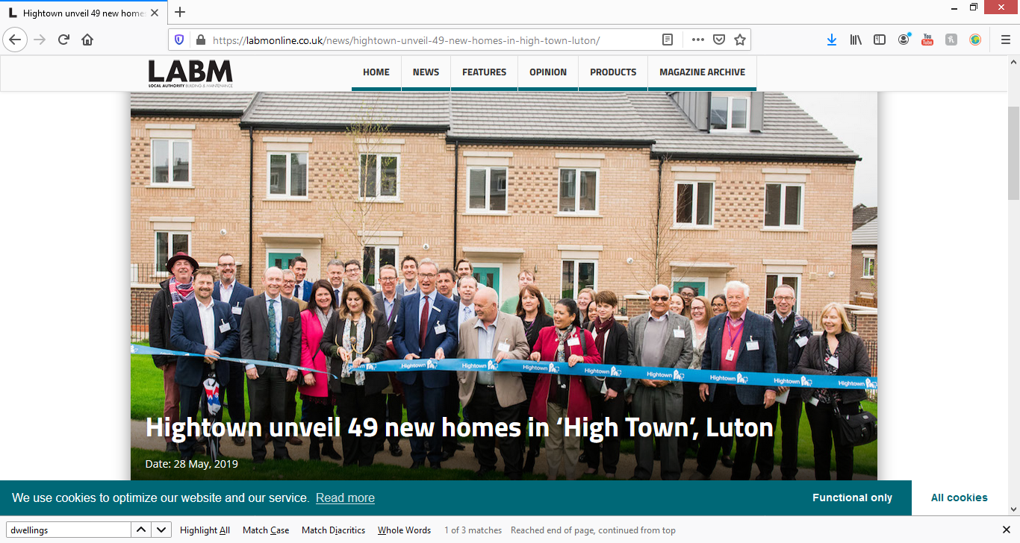
https://www.hightownha.org.uk/corporate-and-development/hatters-place/
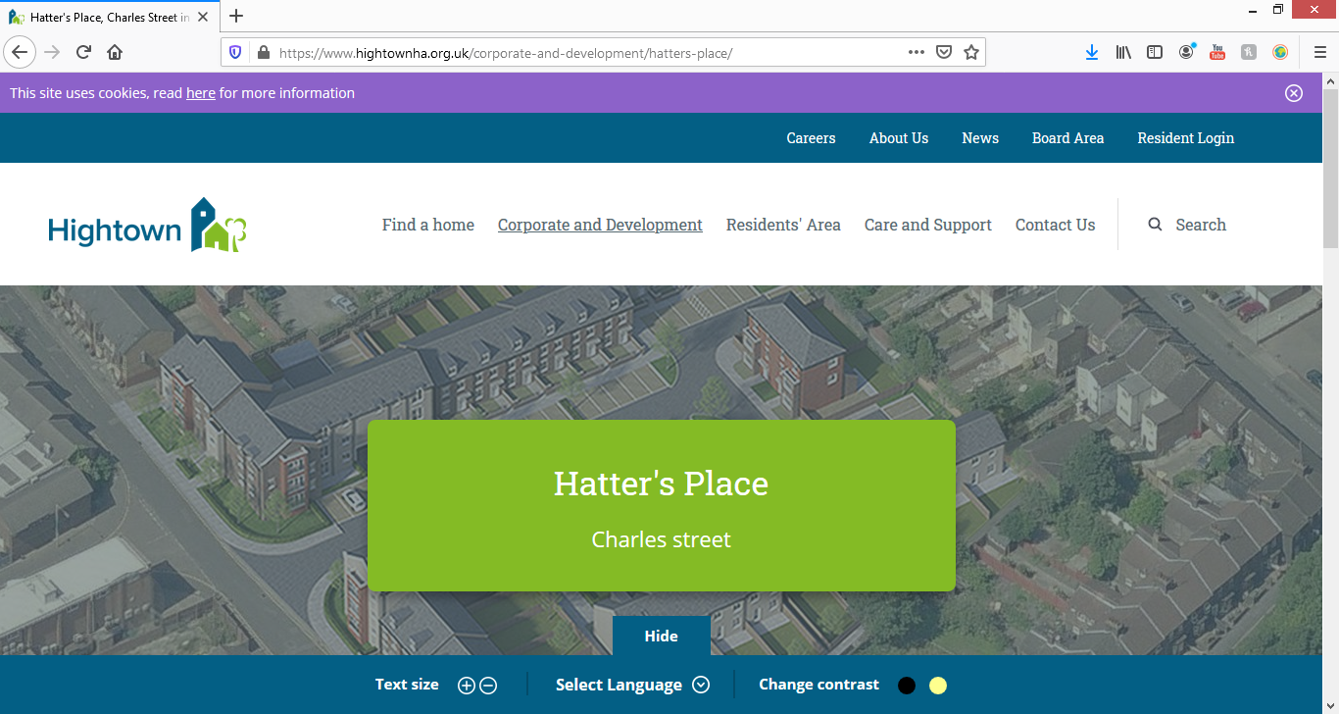
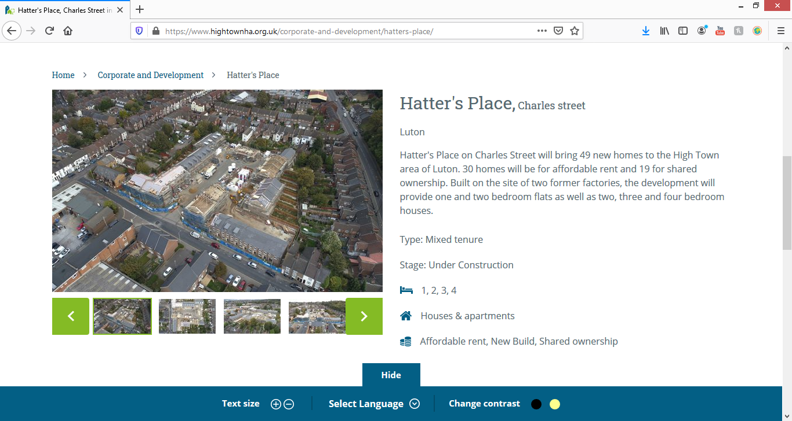
Hatter's Place, Charles street
Luton
Hatter's Place on Charles Street will bring 49 new homes to the High Town area of Luton. 30 homes will be for affordable rent and 19 for shared ownership. Built on the site of two former factories, the development will provide one and two bedroom flats as well as two, three and four bedroom houses.

https://www.surrendeninvest.com/news/brand-new-luton-development-revealed/

Brand new Luton development revealed

One of the most exciting times for a property investment company is finally being able to reveal a new development that you’ve been working on behind the scenes for the past few months. As such, the Surrenden Invest team were delighted to share details of The Orion in Luton with our community of investors earlier in May.

The Orion is home to 67 luxurious apartments, comprising a mix of one- and two-bedroom homes, just a two-minute walk from Luton railway station. Due for completion in Q4 2020, the apartments are priced some 10% below comparable properties on the market.

Their location is a key feature of The Orion’s homes. Commuters can get from Luton to London St Pancras in as little as 22 minutes by direct train. Those travelling abroad, meanwhile, can connect to a range of international destinations at St Pancras, or undertake the 10-minute drive from The Orion to London Luton Airport in order to travel onward to Europe, Africa and the Middle East.

https://natta.co.uk/project/luton/

Project Facts

Sector:
Civil Engineering, Infrastructure & 278 Works

Our Role:
Sub Contractor

Location:
Napier Park, Luton

Client:
Redrow Homes (Eastern)

Project Value:
£16m

Duration:
2 years
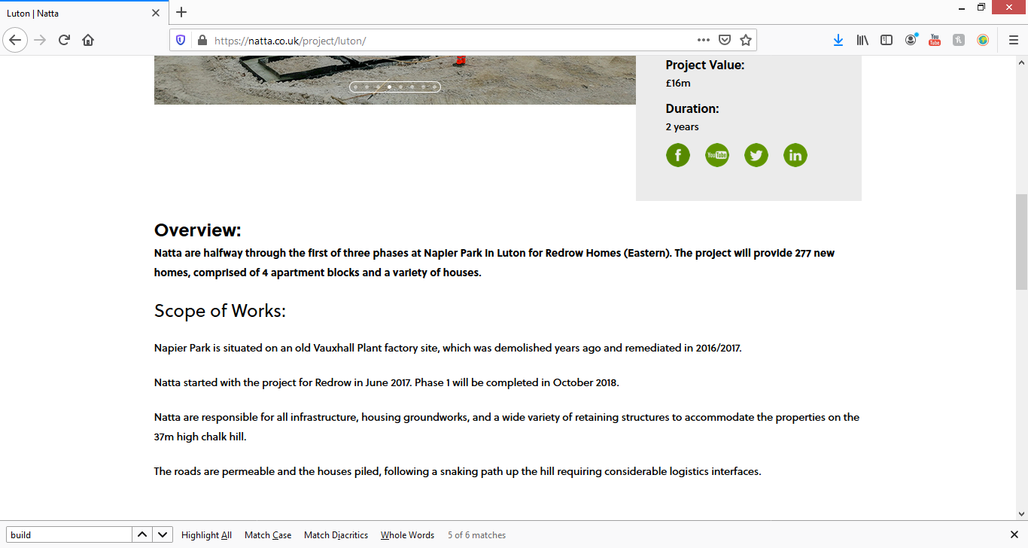

Overview:
Natta are halfway through the first of three phases at Napier Park in Luton for Redrow Homes (Eastern). The project will provide 277 new homes, comprised of 4 apartment blocks and a variety of houses.

Scope of Works:
Napier Park is situated on an old Vauxhall Plant factory site, which was demolished years ago and remediated in 2016/2017.
Natta started with the project for Redrow in June 2017. Phase 1 will be completed in October 2018.
Natta are responsible for all infrastructure, housing groundworks, and a wide variety of retaining structures to accommodate the properties on the 37m high chalk hill.
The roads are permeable and the houses piled, following a snaking path up the hill requiring considerable logistics interfaces.

https://www.nextstepsupport.co.uk/2020/03/02/cannon-kirk-house-luton-opening-9th-of-march-2020/
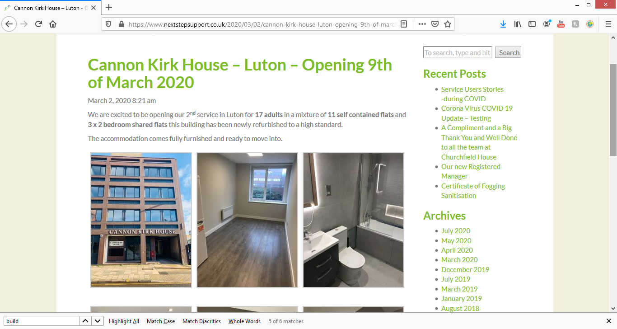

Cannon Kirk House – Luton – Opening 9th of March 2020
March 2, 2020 8:21 am
We are excited to be opening our 2nd service in Luton for 17 adults in a mixture of 11 self contained flats and 3 x 2 bedroom shared flats this building has been newly refurbished to a high standard.
The accommodation comes fully furnished and ready to move into.

https://keypartnershiphomes.co.uk/2019/03/06/caleb-close-luton/
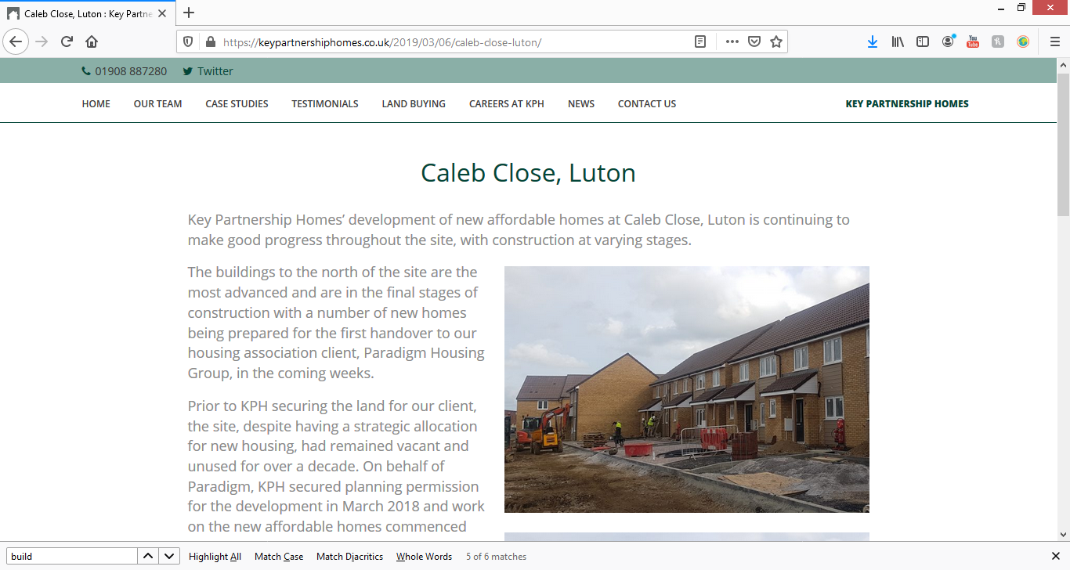

Caleb Close, Luton
Key Partnership Homes’ development of new affordable homes at Caleb Close, Luton is continuing to make good progress throughout the site, with construction at varying stages.
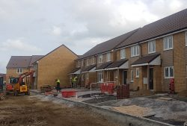
The buildings to the north of the site are the most advanced and are in the final stages of construction with a number of new homes being prepared for the first handover to our housing association client, Paradigm Housing Group, in the coming weeks.
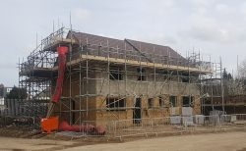
Prior to KPH securing the land for our client, the site, despite having a strategic allocation for new housing, had remained vacant and unused for over a decade. On behalf of Paradigm, KPH secured planning permission for the development in March 2018 and work on the new affordable homes commenced one month later in April 2018.
Managing Director Ian Stimpson said of the development “We are delighted with the progress being made on the site and are proud that KPH is delivering these new affordable homes on one of Luton’s largest remaining brownfield sites. KPH is aware of the issues facing housing in Luton and we are proud to have been able to secure sites in order to meet some of the growing affordable housing need, having handed over 160 affordable homes already in the town over the course of the past 18 months.”
Please feel free to contact KPH with any enquiries related to this or any of our developments. We are also always interested to hear of similar development opportunities that become available and would welcome an initial discussion. The office can be contacted on 01908 887280.
March 6, 2019 10:11 am Published by Key Admin

https://www.paradigmhousing.co.uk/first-new-homes-ready-caleb-close/
Paradigm took official handover of the keys for our first units at Caleb Close in Luton on 1 April, from Key Partnership Homes.
The first phase of this former brownfield site development consists of 16 houses for outright sale.
Caleb Close is currently our largest design and build development and will provide 224 brand new homes, so only 208 units to go! The development is already proving popular with all 16 homes reserved off plan, with our purchasers looking to move in to their new homes within the next couple of weeks.
Caleb Close will deliver 20 three bedroom houses, 21 two bedroom houses, 108 two bedroom flats, and 75 one bedroom flats with associated car parking and landscaping, over the next 18 months.
The tenure split is currently 61 units for affordable rent, 55 units for outright sale, and 108 units for shared ownership (although this split maybe amended to account for any changes in the housing market over the next 18 months).
Upon receiving the keys to the new homes, Glen commented: “I’m delighted we have taken handover for the first 16 units and look forward to welcoming our residents into their new homes. The project team at Key Partnership Homes and Paradigm Housing has worked extremely hard to deliver some really well built and attractive homes. I am looking forward to working with Key Partnership Homes during the next 18 months to deliver a further 208 much needed homes in Luton.”
Matthew commented: “We are excited that the first phase of this key development for Paradigm has been completed and to such a high standard.
“Our mission is to provide homes for people who would otherwise be priced out of the housing market. As well as providing homes for affordable rent, we are providing an opportunity for people to own their own homes.”
This is a fantastic achievement for the Development and Sales Team and we will make sure we keep everyone informed as each phase is completed.
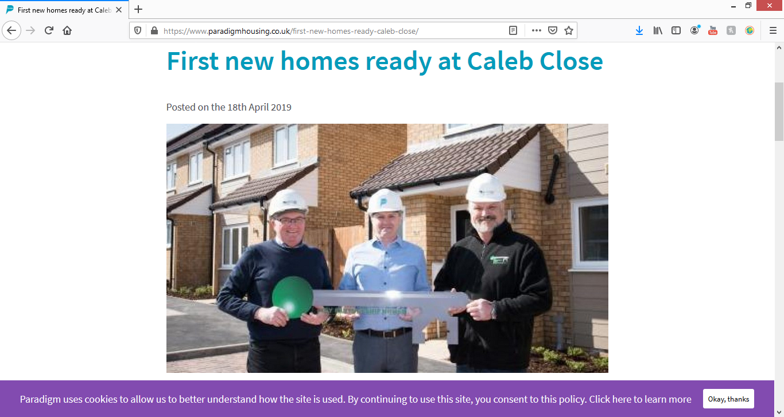

STRAWBERRY STAR – KIMPTON ROAD

Luton Developments
12 August at 07:06 ·
"Strawberry Star Homes recently ‘topped out’ on the first phase of Lu2on, its major, mixed-use development on the site of the former Vauxhall Motors factory, close to Luton Airport.
The £280million project will overall bring provide over 877 suites, one- and two-bedroom apartments together with first-class facilities such as private roof gardens and 24-hour concierge.
The ceremony was attended by Rachel Hopkins, MP for Luton South, Laura Church, corporate director at Luton Council, Tom Neylon, regional director of JJ Rhatigan, representatives from Lu2on architect Flanagan Lawrence, and consultancy Gardiner Theobald amongst other dignitaries and representatives from Strawberry Star."
https://www.whathouse.com/…/strawberry-star-lu2on-phase1-t…/

Luton Developments
12 August at 08:45 ·
Latest images from work at Strawberry Star site on Kimpton Road.
Flats available off-plan. https://www.rightmove.co.uk/property…/property-95362397.html
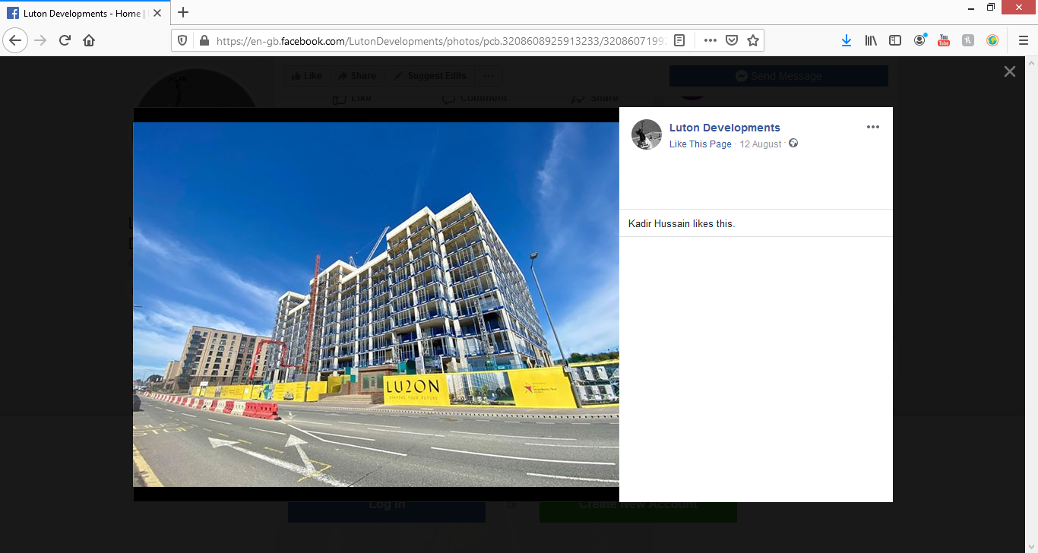
https://www.buildenergy.co.uk/services/part-l-sap-calculations/what-are-sap-calculations/
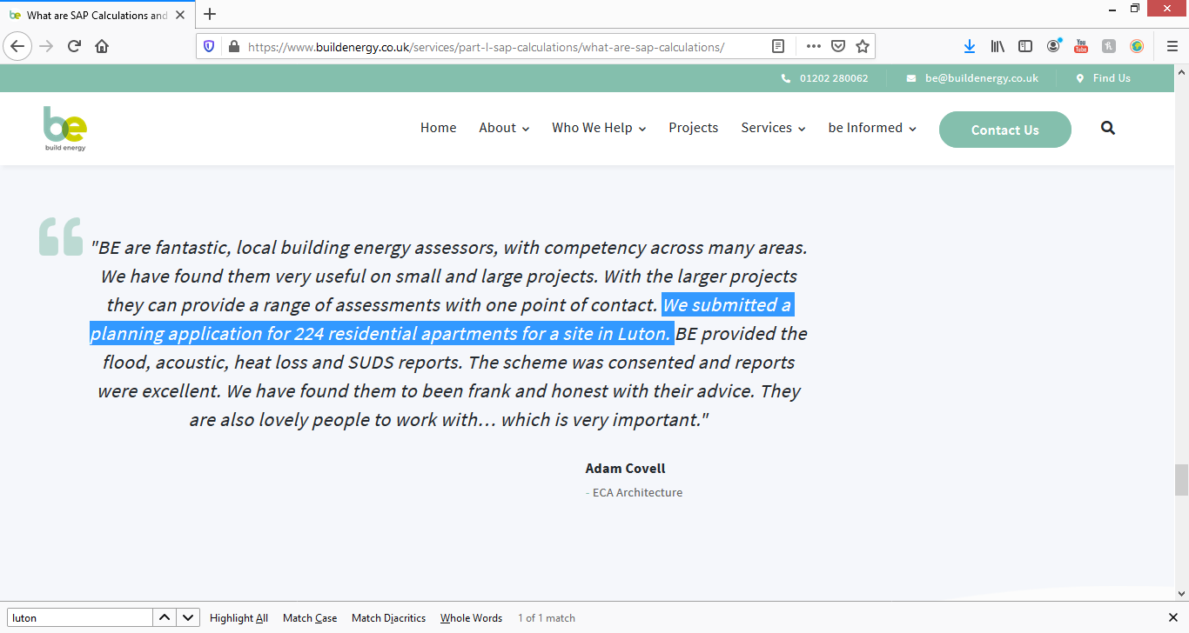
BE are fantastic, local building energy assessors, with competency across many areas. We have found them very useful on small and large projects. With the larger projects they can provide a range of assessments with one point of contact. We submitted a planning application for 224 residential apartments for a site in Luton. BE provided the flood, acoustic, heat loss and SUDS reports. The scheme was consented and reports were excellent. We have found them to been frank and honest with their advice. They are also lovely people to work with… which is very important."
Adam Covell
- ECA Architecture
https://strawberrystar.co.uk/developments/lu2on-london/
© 2020 Strawberry Star Lettings & Sales Ltd. All Rights Reserved
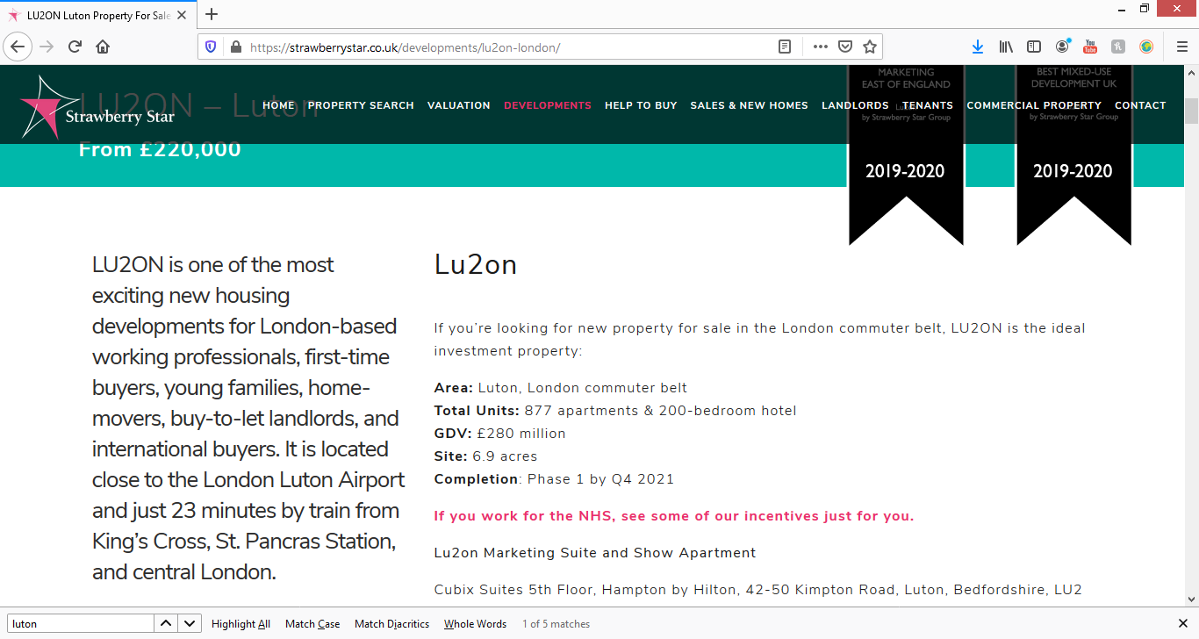
Area: Luton, London commuter belt
Total Units: 877 apartments & 200-bedroom hotel
GDV: £280 million
Site: 6.9 acres
Completion: Phase 1 by Q4 2021
If you work for the NHS, see some of our incentives just for you.
Lu2on Marketing Suite and Show Apartment
Cubix Suites 5th Floor, Hampton by Hilton, 42-50 Kimpton Road, Luton, Bedfordshire, LU2

https://www.redrow.co.uk/newsroom/south-south-east/2017/3/new-redrow-homes-coming-soon-in-luton
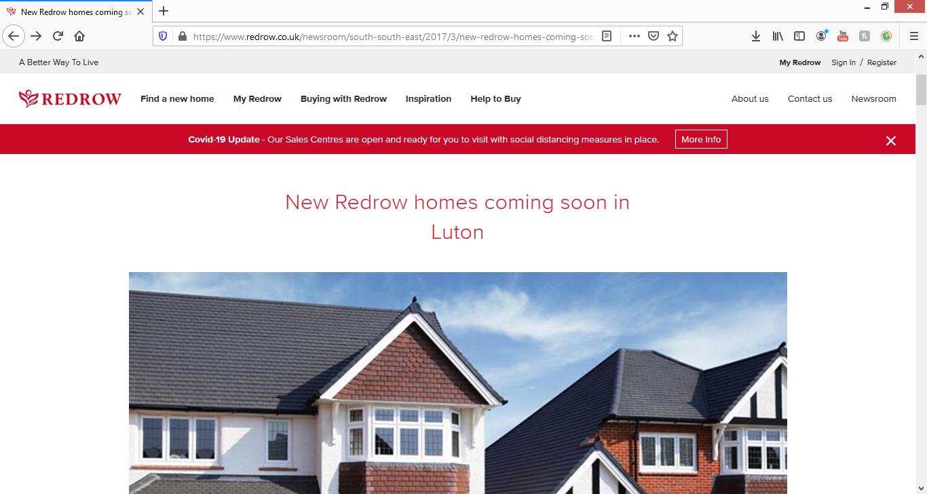
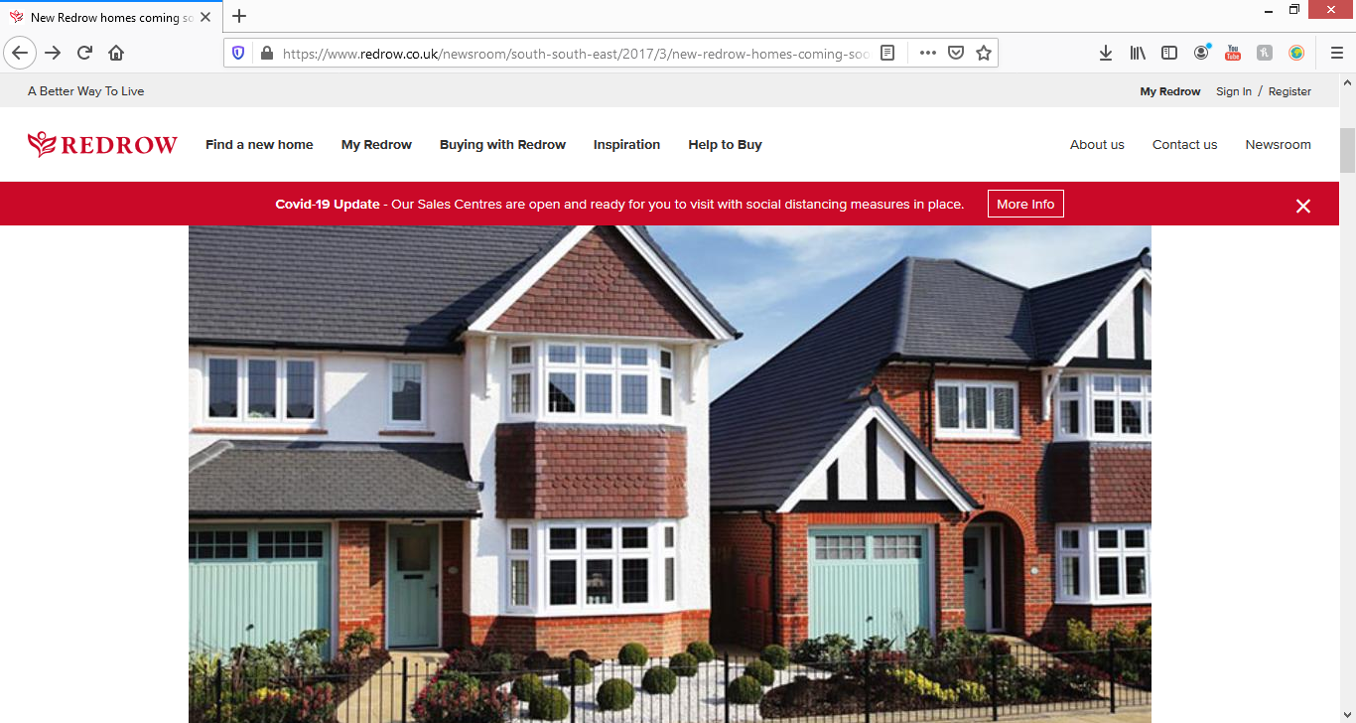
*Updated 08/08/2018*
Luton homebuyers will continue to have new homes to choose from with homes coming soon in several developments, due to Redrow Luton investing in the area.
The award-winning housebuilder Redrow built around 520 properties on a 20-acre site, available via two outlets – Volanti, with bespoke-design apartments, and Eaton Green Heights, with properties from the Heritage Collection.
Kerry McCoubrey, sales director for Redrow Homes (Eastern), said: “This part of Luton is undergoing major investment and we’re proud to be playing our part in revitalising the area to provide much needed new homes. The Heritage Collection is our most popular range of homes and we’re already seeing strong interest from potential purchasers. People love that these designs offer the charm and character of ‘period’ properties, with all the style and convenience of being brand new and no costly repairs or renovations required.”
https://indigo-res.co.uk/property/mullion-close-stopsley-luton-bedfordshire-lu2-7fs/

Maisonette Available
Mullion Close, Stopsley, Luton, Bedfordshire, LU2 7FS
£185,000
Leasehold
• Built In 2018
• Ideal First Time Buy/Buy to Let
• Local Shops Close By
• Immaculate Condition Throughout
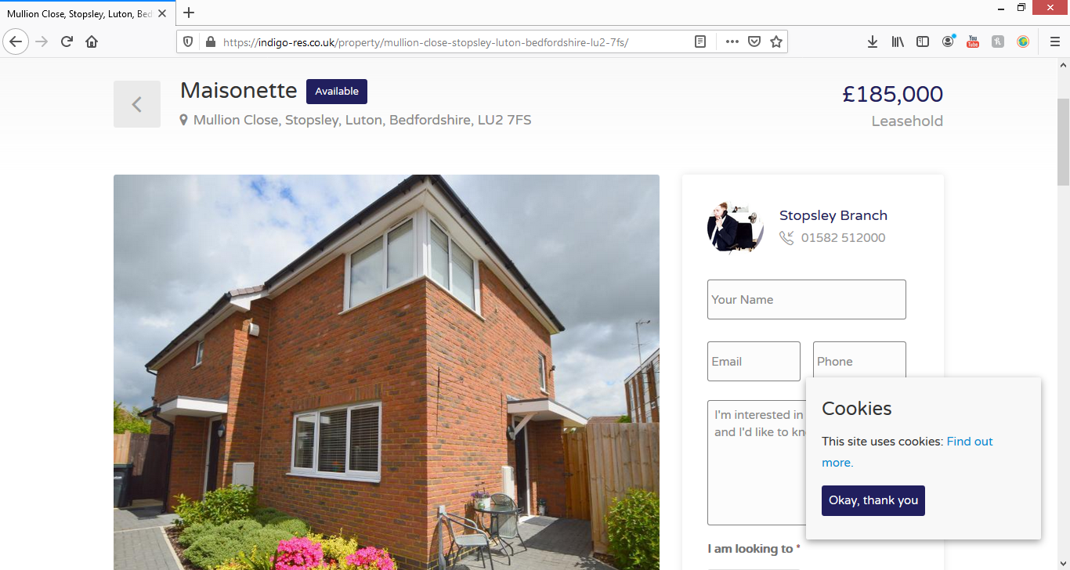

http://bulkloader.prd.pl.artirix.com.s3.amazonaws.com/206711ce-bc28-4a3f-a344-b17e1c6a37a5_Details.pdf
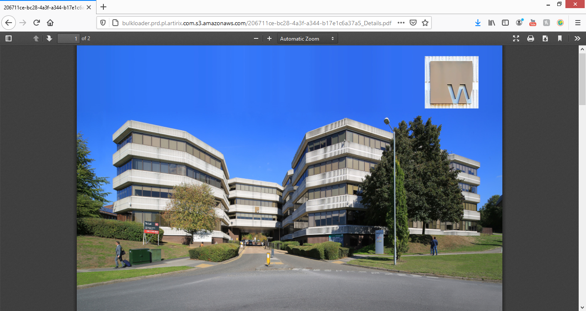
1ST FLOOR, MARLBOROUGH HOUSEWigmore Place | Luton | LU2 9EX

Planning to change to flats.

https://www.persimmonhomes.com/new-homes/bedfordshire/luton
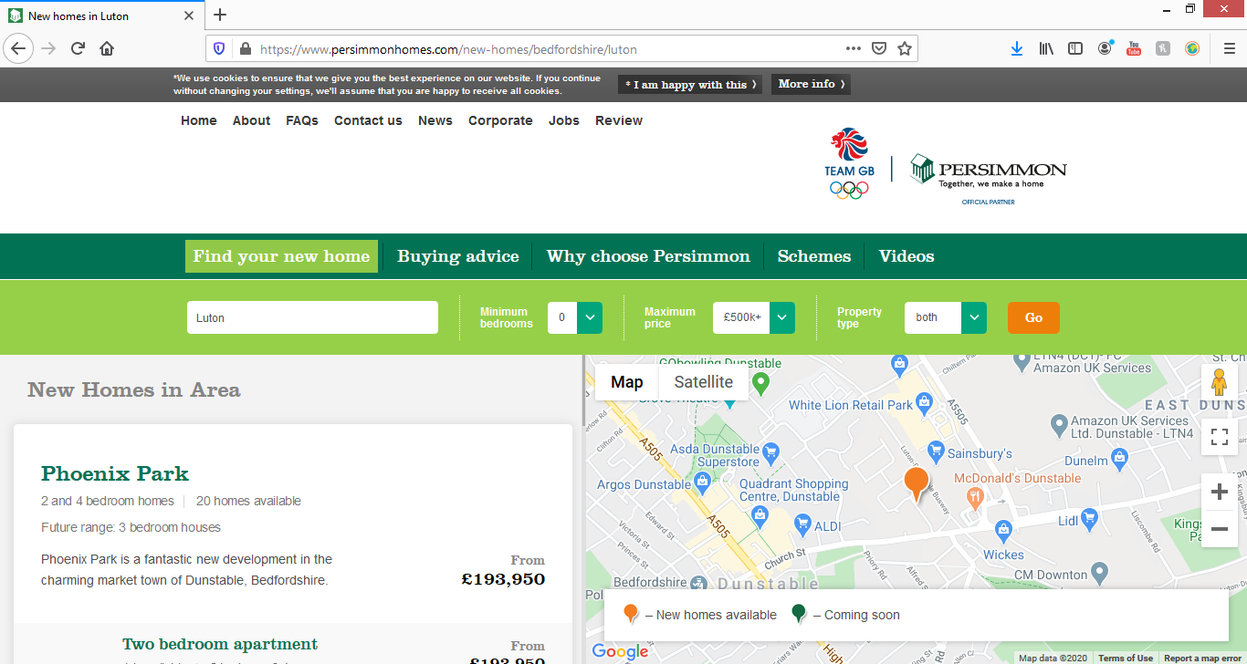
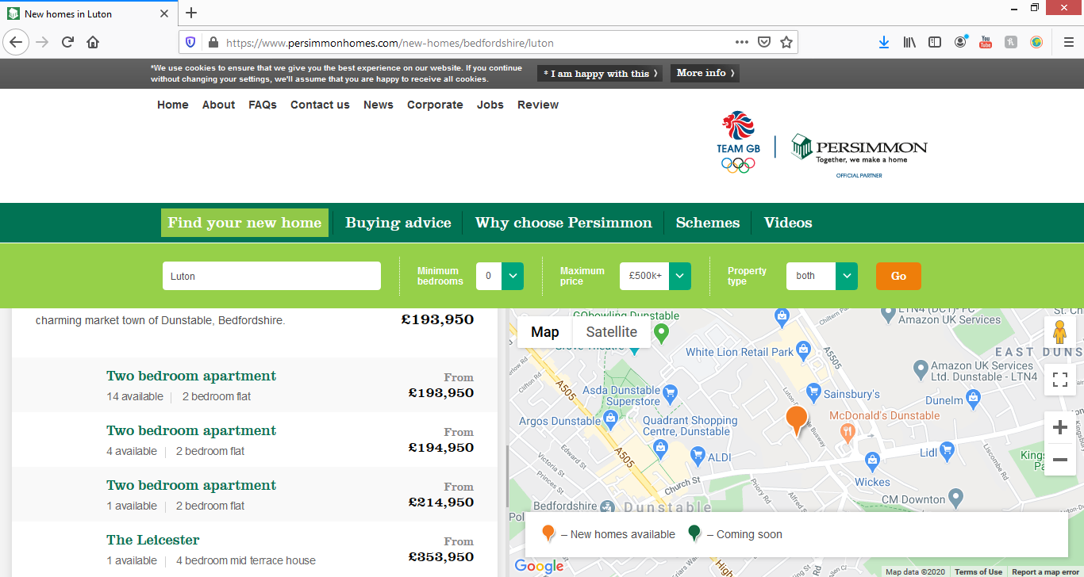

https://www.chg.org.uk/development-regeneration/development/our-development-schemes/luton/

Luton, Bedfordshire
The new homes for Luton programme will deliver up to 450 affordable and 150 private sale homes on a number of sites over a nine year period.
The aim of this project is to deliver a significant number of affordable family homes on mixed tenure developments.
There will be employment opportunities onsite, offering local people a range of apprenticeships.The programme is being delivered through a partnership between Catalyst, Luton Borough Council, Luton Learning and Community Partnership, The Homes and Communities Agency and Wates Living Space.
The scheme is fully mixed tenure, with private sale receipts being used to subsidise the affordable homes.
Work started onsite in 2011. Phase 1 consists of three sites – Hart Hill, Wigmore Lane and Falconers Road where 152 new homes have been built.
The second phase of new homes for Luton started in mid-2013 and will build 209 new homes across three sites. The new homes will be a mix of private sale (100 properties), shared ownership (44 properties) and affordable rent (65 properties).
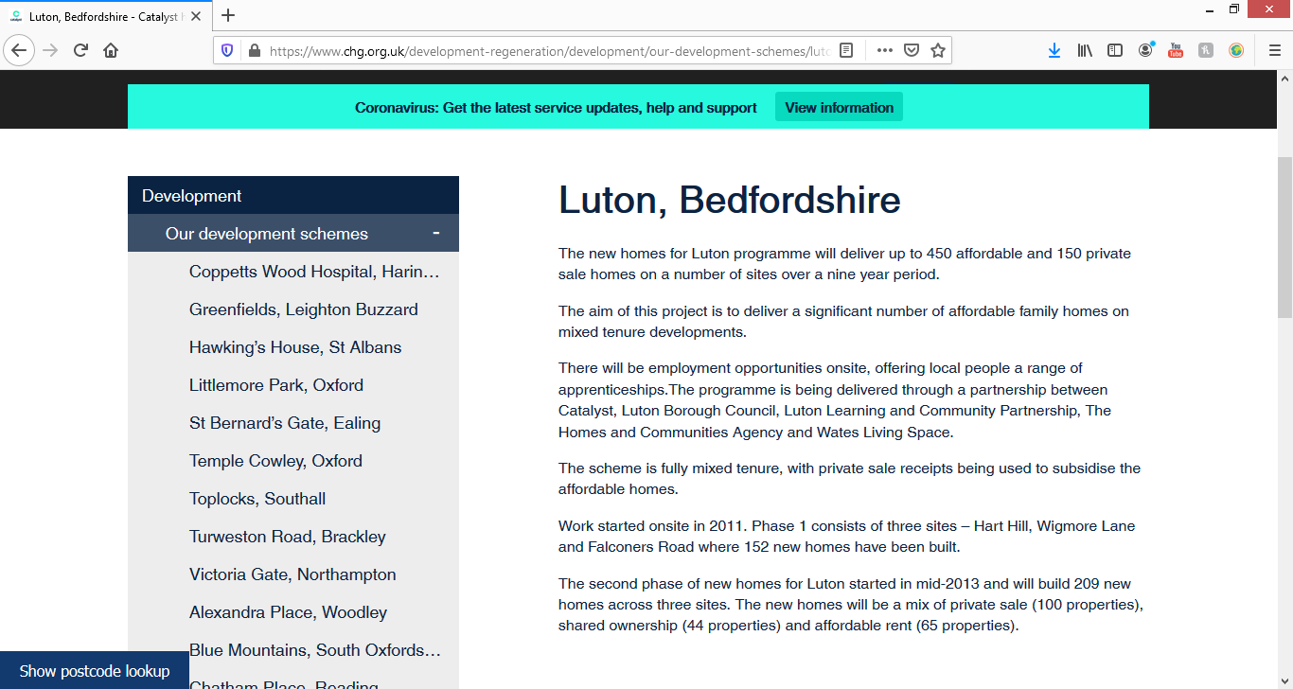

https://www.millinersplace.com/
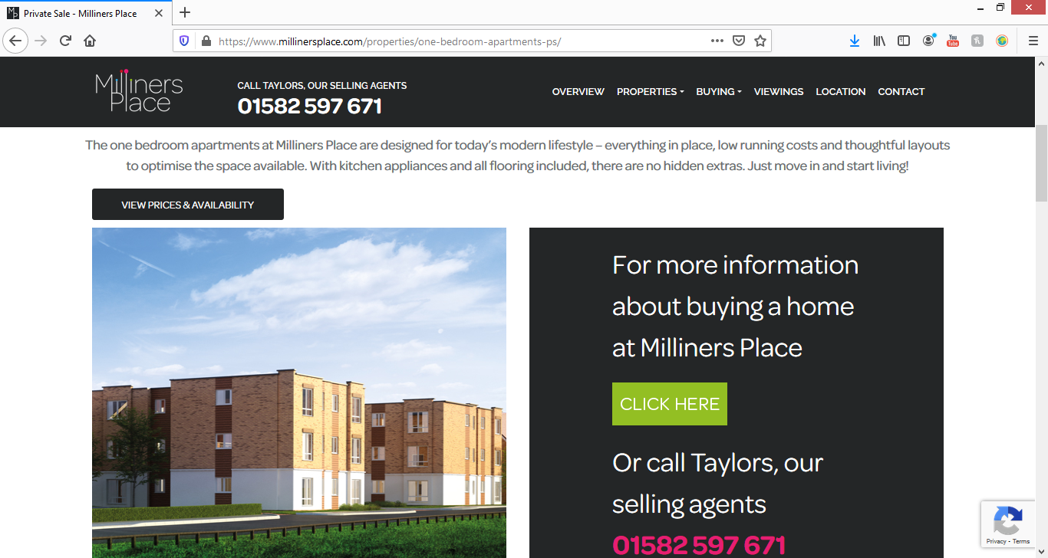
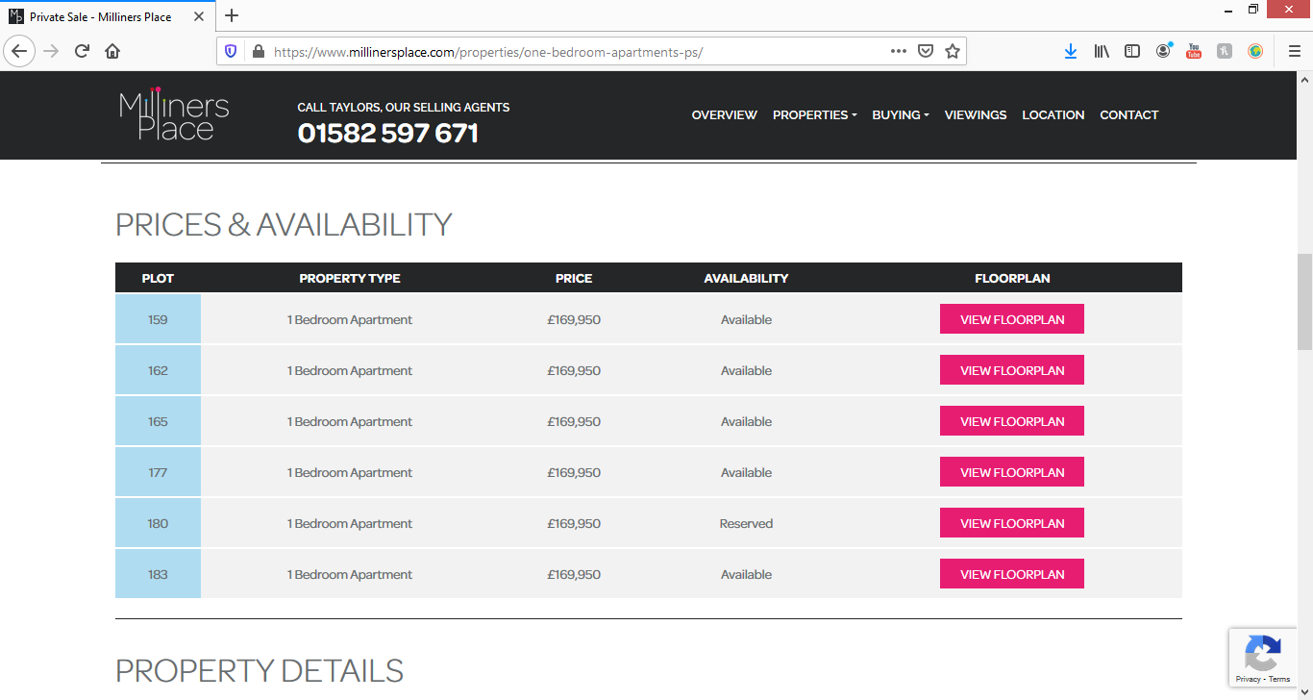

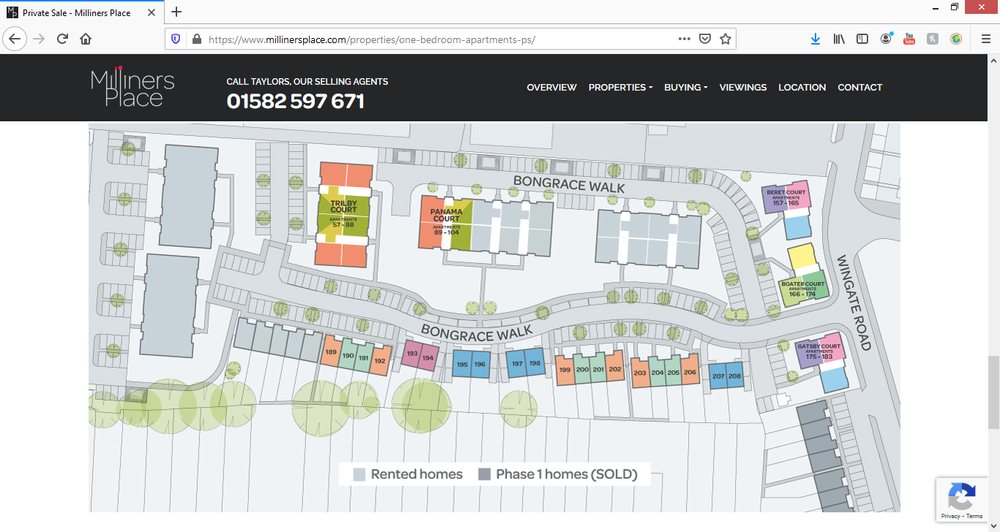

DEVELOPED BY
Paradigm Housing Group
1 Glory Park, Wooburn Green,
High Wycombe HP10 0DF
Tel: 0845 337 4877
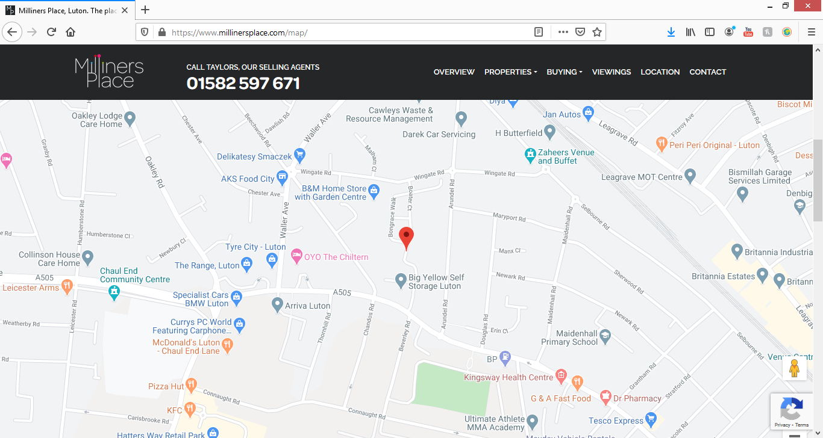

https://core-personnel.co.uk/project/carlton-house/
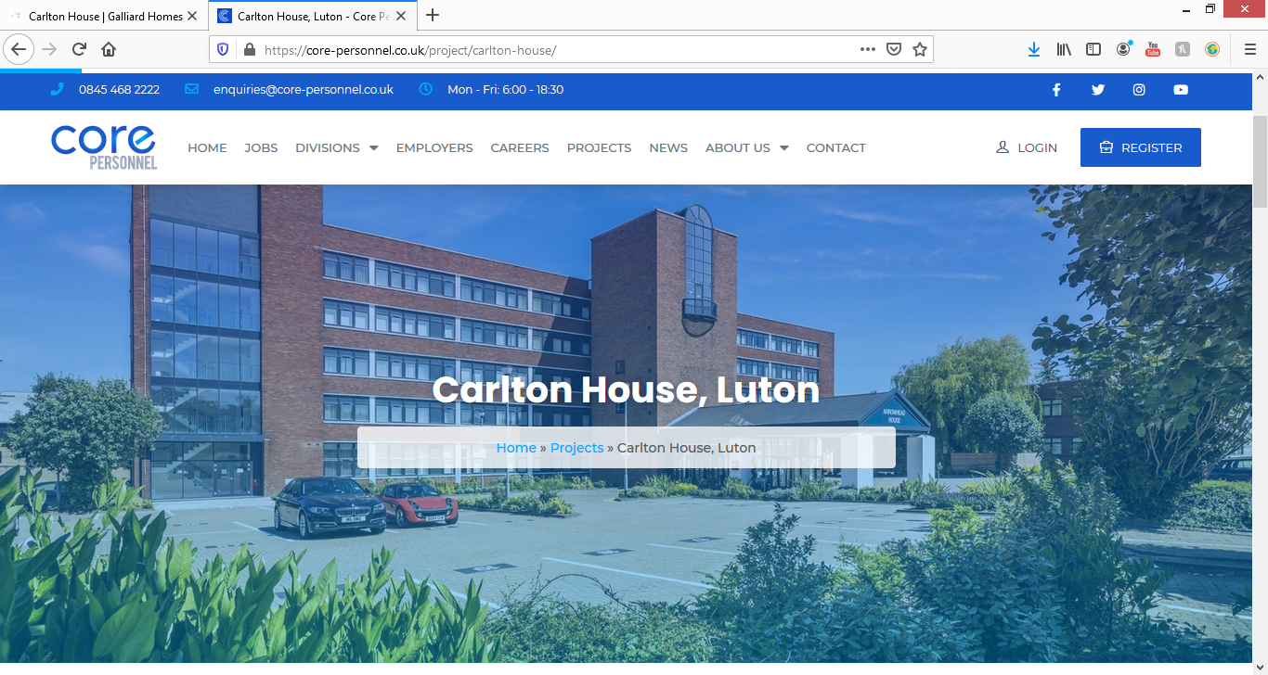

Project Summary
Galliard Homes development of the former office building into a a modern assorted studios to one and two-bedroom apartments, located in Bedfordshire, approximately 33 miles north of Central London, Luton.

Key Statistics
Selection of studio, one and two-bedroom apartments
Premier specifications and contemporary finishes
11-minute drive to Luton station
15-minute walk to Luton Town Centre
Approximately 33 miles north of Central London

Carlton House, Laporte Way, Luton

Asking price £210,000, 2 bedrooms, Flat,
https://www.facebook.com/LutonDevelopments/posts/1079099645530849

Luton Developments
27 September 2016 ·
Luton based Ashton Carter International are marketing 100 flats in Carlton House, the latest Galliard Homes development in Luton. The flats are being sold as a single portfolio for offers in the region of £18m.

https://catalyst.homes/development/caddington-woods/
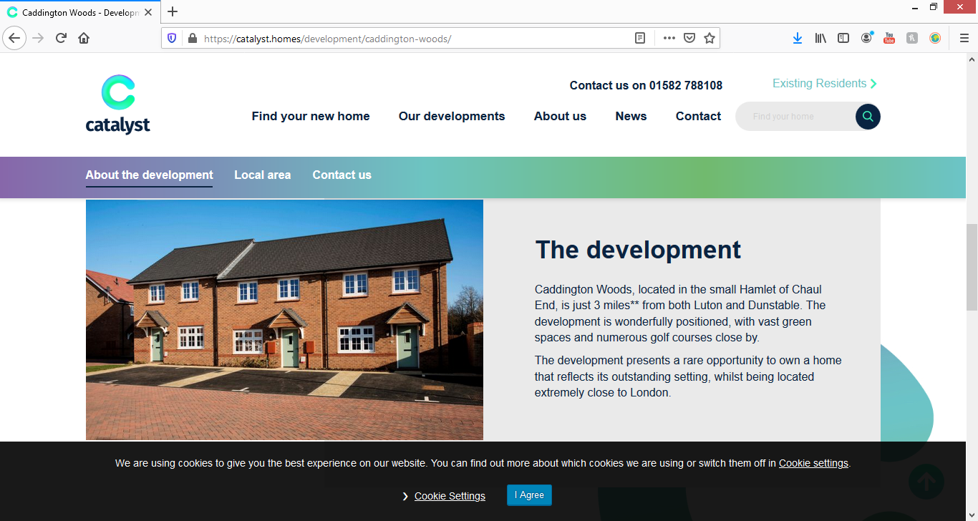
The development
Caddington Woods, located in the small Hamlet of Chaul End, is just 3 miles** from both Luton and Dunstable. The development is wonderfully positioned, with vast green spaces and numerous golf courses close by.
The development presents a rare opportunity to own a home that reflects its outstanding setting, whilst being located extremely close to London.
https://www.facebook.com/LutonDevelopments/posts/new-homes-for-sale-at-felstead-way-httpswwwrightmovecoukproperty-for-salepropert/2665845620189569/
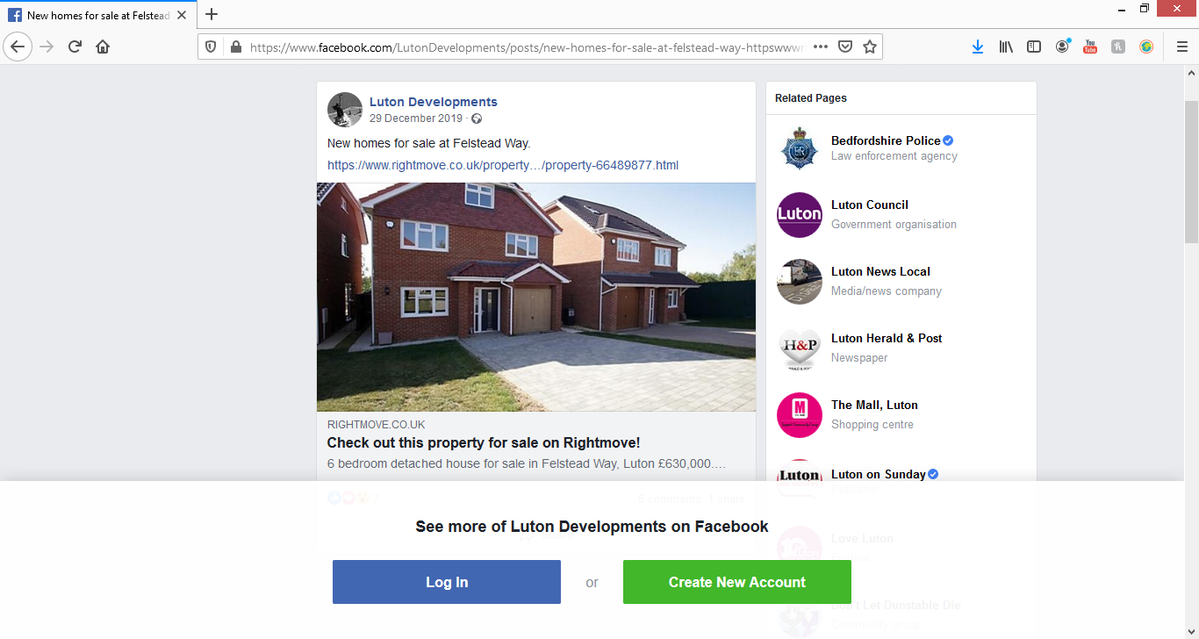
15 sold properties
Date sold
78, Felstead Way, Luton LU2 7LJ
Semi-Detached
£550,000 | 10 Jul 2019(New Build) | Freehold
No other historical records

75, Felstead Way, Luton LU2 7LJ
Detached
£595,000 | 18 Apr 2019(New Build) | Freehold
No other historical records

80, Felstead Way, Luton LU2 7LJ
Semi-Detached
£550,000 | 4 Apr 2019(New Build) | Freehold
No other historical records

69, Felstead Way, Luton LU2 7LJ
Detached
£705,000 | 21 Dec 2018(New Build) | Freehold
No other historical records

NEWLANDS:
https://www.lutontown.co.uk/news/2019/march/newlands-park/

NEWLANDS PARK APPROVED!
2020 Developments game-changing plans for Newlands Park given the go-ahead by Luton Borough Council’s development control committee.
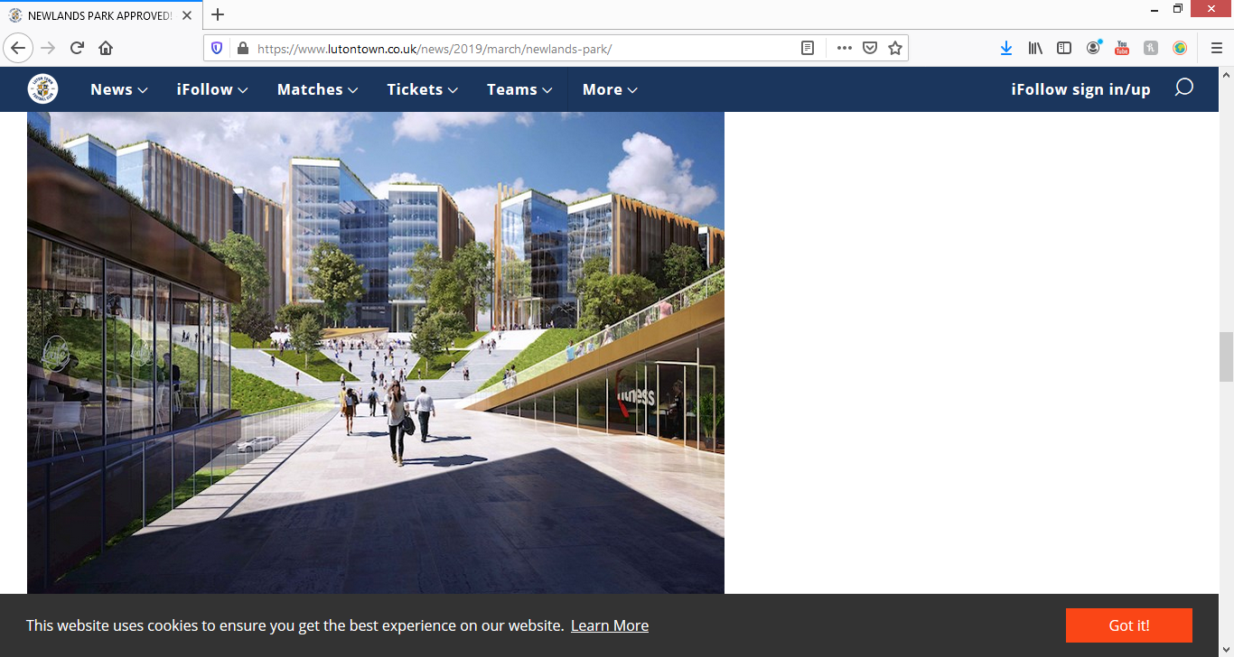

https://thinkluton.co.uk/key-developments/luton-2020-developments/
2020 Developments is the company behind Luton Town Football Club and its associated development plans.
As announced in December 2016, the preferred location for the club’s new state-of-the-art stadium is Power Court in Luton town centre. In addition to the 17,500 – 23,000 seater iconic stadium to support the club’s football ambitions, the development vision sees the landmark 20 acre Power Court site revived to a state of vibrancy and aspiration that will help shape the town’s value and character.
The major mixed-use development scheme proposals being pursued would include venues for live sport and music, further leisure alongside an appropriate scale of lifestyle retail facilities, circa 560 residential apartments and other valuable amenities.
The facilitating development to drive this town centre project is a major mixed-use gateway scheme at Junction 10 of the M1, named Newlands Park.

https://www.rightmove.co.uk/property-for-sale/property-71465196.html

24 bedroom block of apartments for sale
Newlands Road, Luton
£2,700,000

ey features
- Block of 12 Two bedroom Two bathroom apartments with balconies
- Other blocks also available

Full description
*** FULL BLOCK PLANS AVAILABLE UPON REQUEST *** COMPLETION DECEMBER 2020 *** £144,000 PA rental income ***Stockwood gardens is an exciting new build project of 11 separate residential blocks of luxury executive apartments with secure allocated parking and private terraces and balconies. The scheme offers a great mix of one and two bedroom properties of differing sizes to suit all budgets.

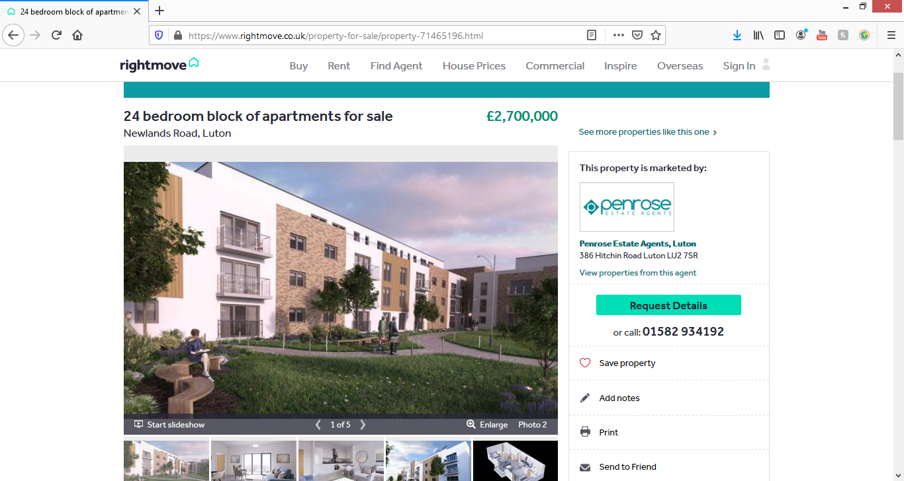
https://www.zoopla.co.uk/new-homes/details/55861506?search_identifier=2fc000b604d0cf3a882ab3181e233969
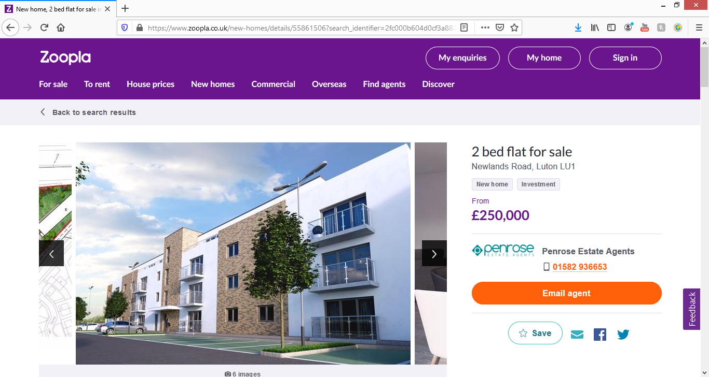

2 bed flat for sale

Newlands Road, Luton LU1
- New home
- Investment
From
£250,000

Description
***exclusive to Penrose Estate Agents*** early reservations being taken now*** stamp duty and furniture pack incentives available ***
This two bedroom penthouse apartment boasts en suite to master bedroom, private terrace, stunning open plan living area and allocated parking.
Stockwood gardens is an exciting new build project of 11 separate residential blocks of luxury executive apartments with secure allocated parking and private terraces and balconies. The scheme offers a great mix of one and two bedroom properties of differing sizes to suit all budgets. The site is situated within the sought after South Luton area of the town on the fringes of Stockwood Country Park not only offering exclusive living but great amenities including Stockwood Park golf club, riding school and activity centre. Transport links from this site are in abundance with M1 junction 10 within 1/4 mile, Luton town centre train station within 1.5 miles and Luton airport all providing direct links to London and beyond.
The scheme offers an excellent option for any first time buyer starting on the ladder and investors alike with a booming rental market within the town offering great returns and quality tenants.

https://www.zoopla.co.uk/for-sale/property/bedfordshire/luton/?is_auction=false&is_retirement_home=false&is_shared_ownership=false&keywords=new%20build&q=Luton%2C%20Bedfordshire&results_sort=newest_listings&search_source=home

- 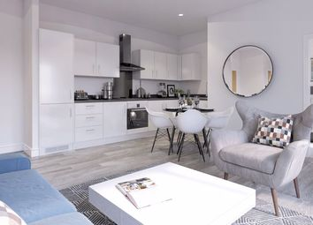
- 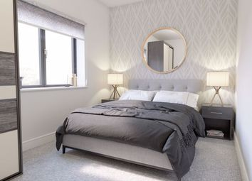
- 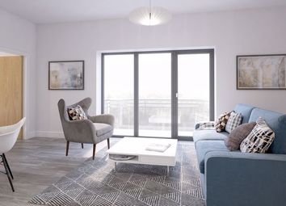
- 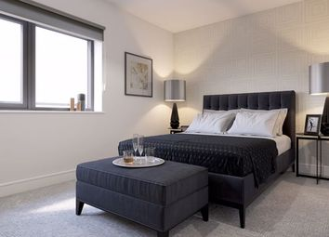
- 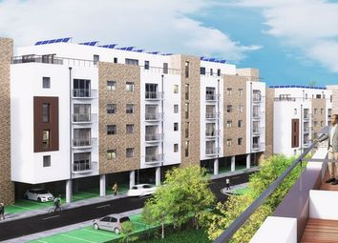

New build

6
£219,995 From

2 2 1

2 bed flat for sale Just added
Newlands Road, Luton LU1
***exclusive to penrose estate agents*** early reservations being taken now*** stamp duty and furniture pack incentives available *** This two bedroom apartment boasts en suite to master bedroom, balcony, stunning open plan living area and allocated ...
- Luton (1.5 miles)
- Luton Airport Parkway (1.6 miles)
Listed on 17th Aug 2020 by
Penrose Estate Agents, LU2
01582 936653 ** Contact Save Hide

- 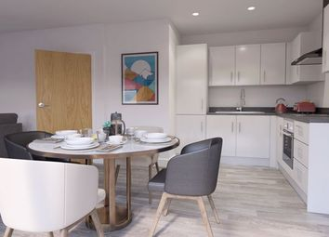
- 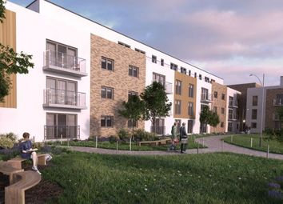
- 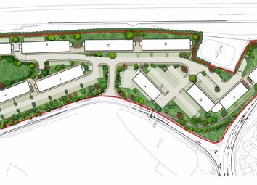

New build

6
£250,000 From

2 2 1

2 bed flat for sale
Newlands Road, Luton LU1
***exclusive to penrose estate agents*** early reservations being taken now*** stamp duty and furniture pack incentives available *** This two bedroom penthouse apartment boasts en suite to master bedroom, private terrace, stunning open plan living ...
- Luton (1.5 miles)
- Luton Airport Parkway (1.6 miles)
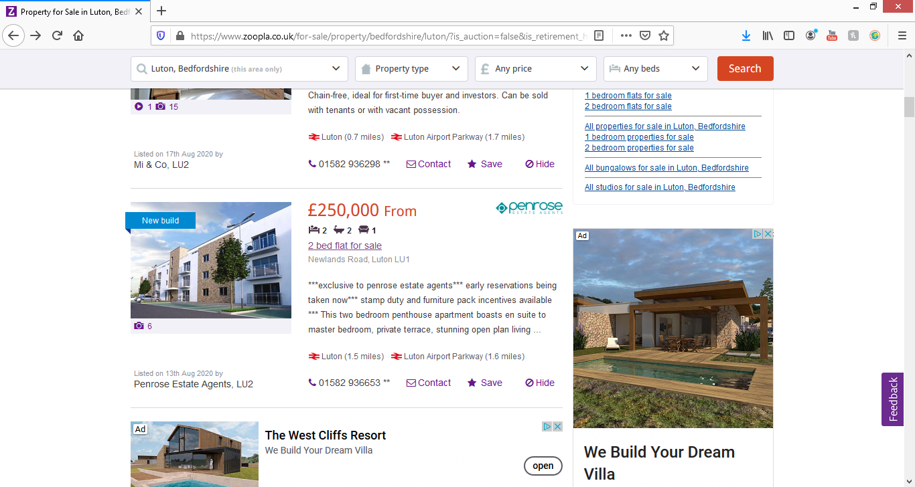

https://en-gb.facebook.com/LutonDevelopments/photos/pb.108999545874202.-2207520000../3226548207452638/?type=3&theater
Luton Developments
· Yesterday · 19 August 2020

Plans have been submitted to change the parking plans at the Newlands Road development currently under construction.
The site will be home to 340 flats. The original plans had underground parking, the application seeks to eliminate all of the underground parking and convert landscaped garden space to car parking instead.
https://planning.luton.gov.uk/online-applications/applicationDetails.do?activeTab=documents&keyVal=QF7AFCKGIVL00
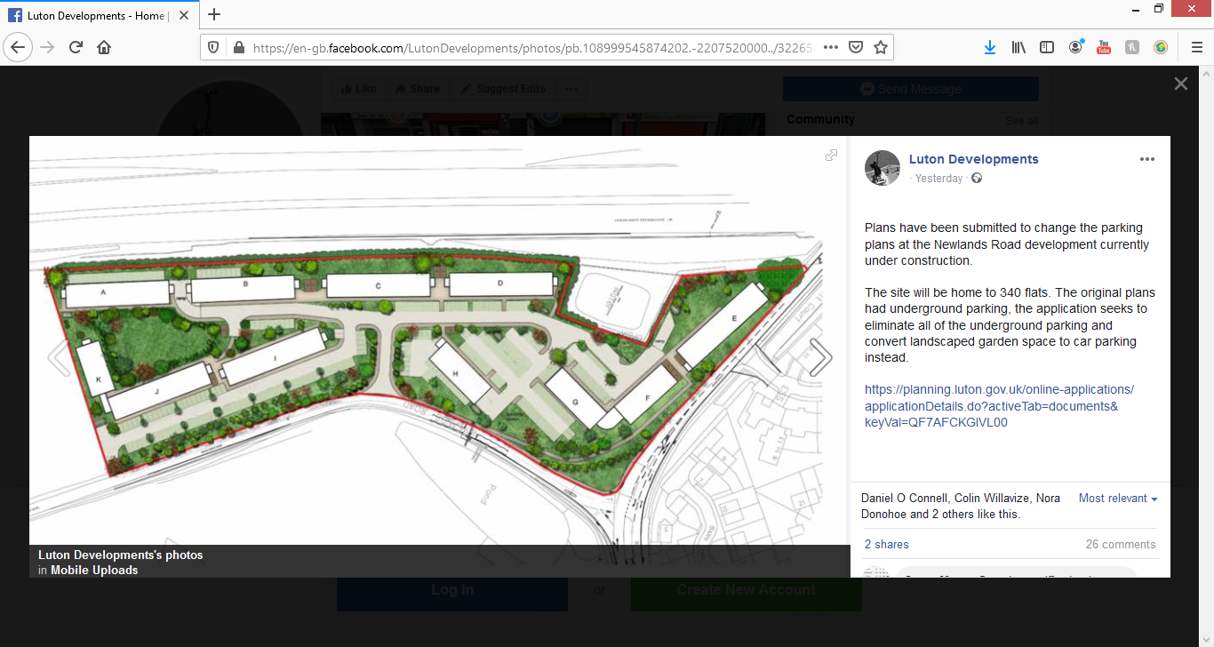

FREEMANS COMMON:

https://en-gb.facebook.com/LutonDevelopments/photos/pb.108999545874202.-2207520000../3228829487224510/?type=3&theater
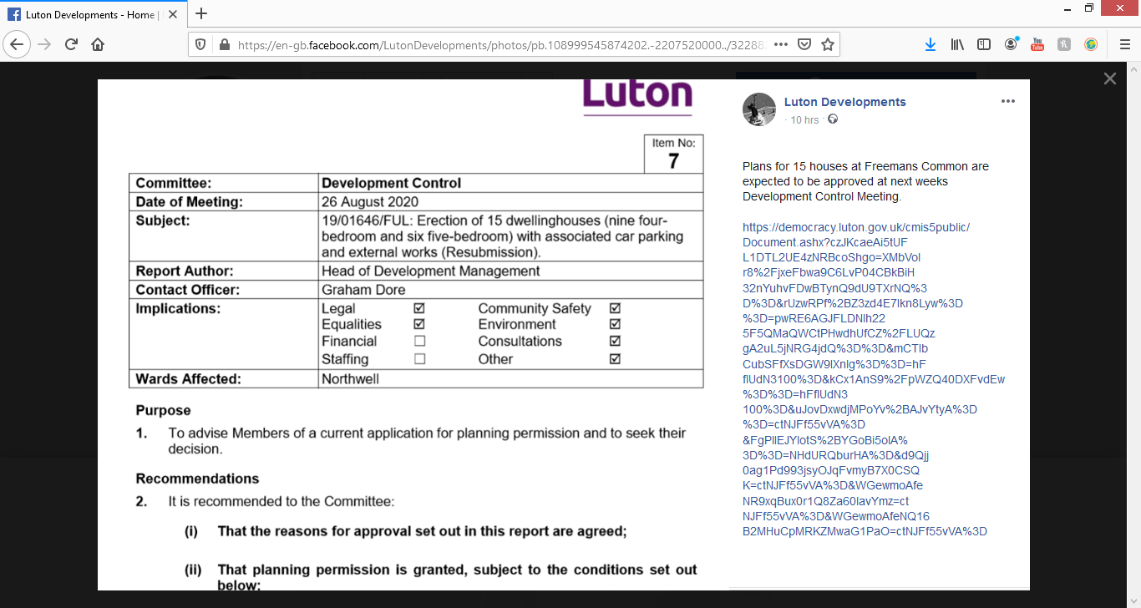
https://democracy.luton.gov.uk/cmis5public/Document.ashx?czJKcaeAi5tUFL1DTL2UE4zNRBcoShgo=XMbVolr8%2FjxeFbwa9C6LvP04CBkBiH32nYuhvFDwBTynQ9dU9TXrNQ%3D%3D&rUzwRPf%2BZ3zd4E7Ikn8Lyw%3D%3D=pwRE6AGJFLDNlh225F5QMaQWCtPHwdhUfCZ%2FLUQzgA2uL5jNRG4jdQ%3D%3D&mCTIbCubSFfXsDGW9IXnlg%3D%3D=hFflUdN3100%3D&kCx1AnS9%2FpWZQ40DXFvdEw%3D%3D=hFflUdN3100%3D&uJovDxwdjMPoYv%2BAJvYtyA%3D%3D=ctNJFf55vVA%3D&FgPlIEJYlotS%2BYGoBi5olA%3D%3D=NHdURQburHA%3D&d9Qjj0ag1Pd993jsyOJqFvmyB7X0CSQK=ctNJFf55vVA%3D&WGewmoAfeNR9xqBux0r1Q8Za60lavYmz=ctNJFf55vVA%3D&WGewmoAfeNQ16B2MHuCpMRKZMwaG1PaO=ctNJFf55vVA%3D
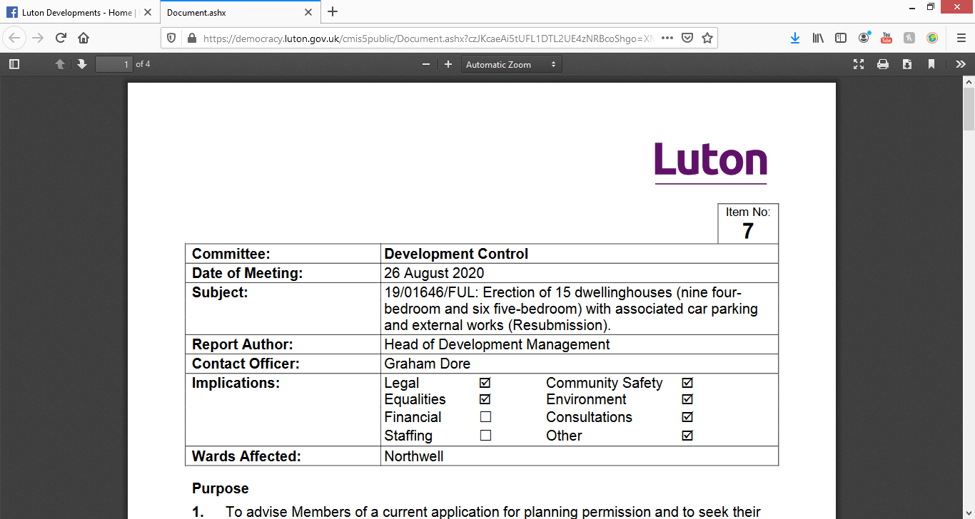
26 August 2020Subject:19/01646/FUL: Erection of 15 dwelling houses (nine four-bedroom and six five-bedroom) with associated car parking and external works (Resubmission).

SAXON SQUARE
https://www.redrow.co.uk/developments/saxon-square-luton-442512
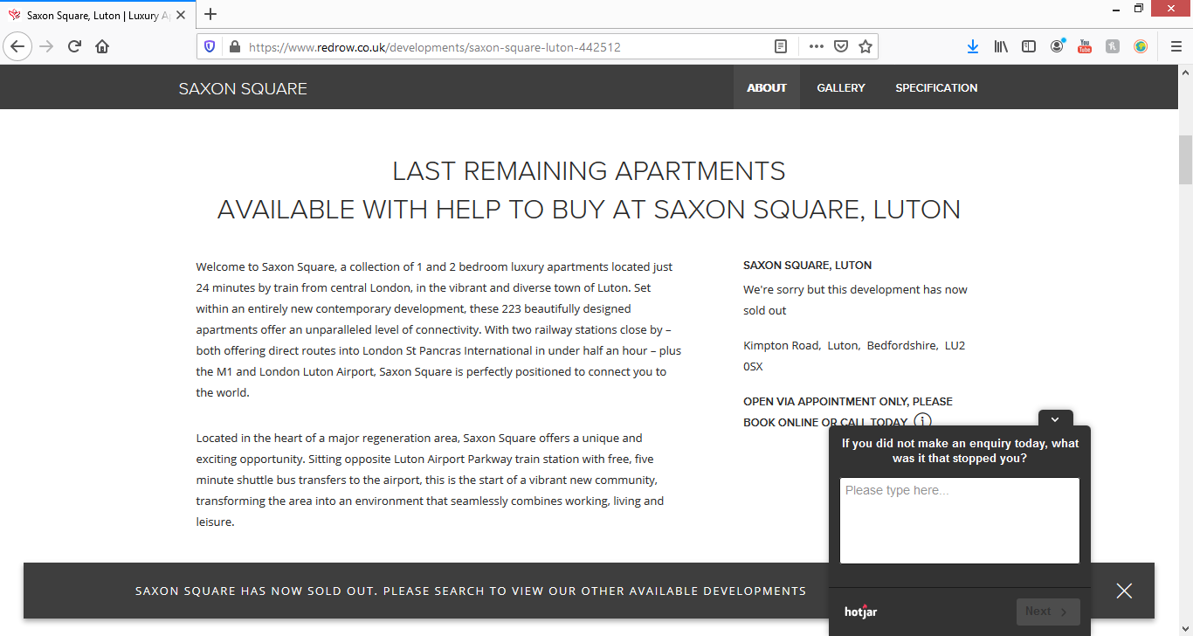

Last remaining apartments
available with Help to Buy at Saxon Square, Luton

Saxon Square, Luton
We're sorry but this development has now sold out
Kimpton Road, Luton, Bedfordshire, LU2 0SX
Open via appointment only, please book online or call today
Welcome to Saxon Square, a collection of 1 and 2 bedroom luxury apartments located just 24 minutes by train from central London, in the vibrant and diverse town of Luton. Set within an entirely new contemporary development, these 223 beautifully designed apartments offer an unparalleled level of connectivity.

PARK CRESCENT
https://www.zoopla.co.uk/new-homes/details/55780030?search_identifier=2fc000b604d0cf3a882ab3181e233969
£173,000

1 1 1

1 bed flat for sale
Park Street, Luton LU1
Park Crescent, a high-specification residential development is just 400 metres from Luton Rail Station and is adjacent to The University of Bedfordshire Luton campus.
- Luton (0.3 miles)
- Luton Airport Parkway (0.7 miles)
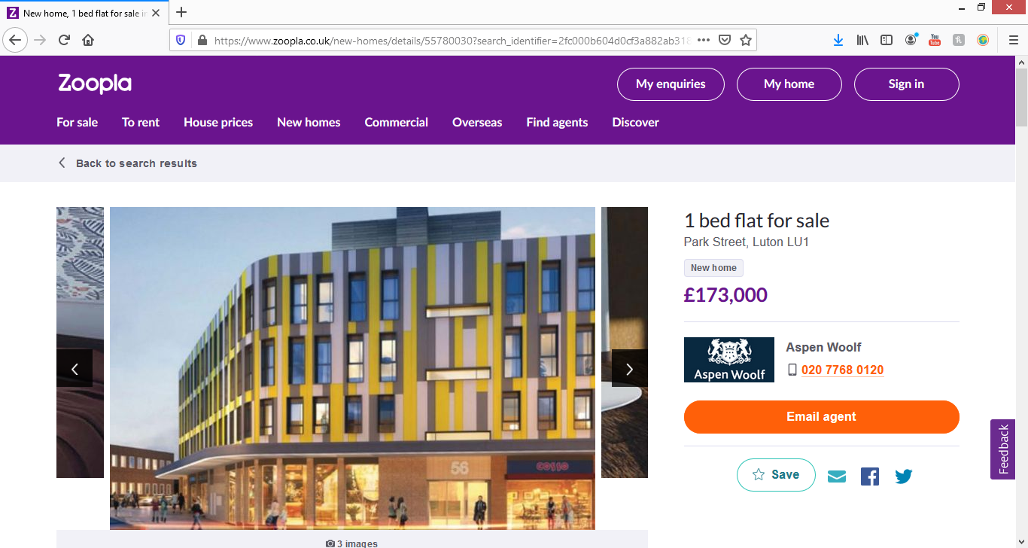

Description
Park Crescent residential development is just 400 metres from Luton Rail Station and is adjacent to The University of Bedfordshire Luton campus. The four storey building boasts 42 beautifully designed, high specification, one bedroom and studio apartments. The ground floor is set aside for commercial purposes. The exterior is being completely remodelled with the introduction of new windows and doors and the whole facade covered in an intricate system of insulated coloured renders.

RIDGWAY
https://www.zoopla.co.uk/new-homes/details/51092096?search_identifier=2fc000b604d0cf3a882ab3181e233969
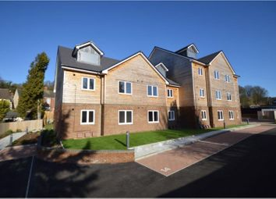
New build

16
£240,000

2 1 1

2 bed flat for sale
Ridgway Road, Luton LU2
+++new build property+++offered with the option of 'help to buy'+++new lease+++ we are delighted to offer for sale this ground floor flat located within easy walking distance of Luton Mainline Railway Station and offered with the added advantage of ...
- Luton (0.5 miles)
- Luton Airport Parkway (1.1 miles)

Description
+++new build property+++offered with the option of 'help to buy'+++new lease+++
we are delighted to offer for sale this ground floor flat located within easy walking distance of Luton Mainline Railway Station and offered with the added advantage of Help To Buy is this exclusive development of two bedroom, two bathroom flat with an allocated parking space.
Alice Court is situated off Ridgway Road and is ideally located for a range of shops, services and amenities as well as local schools.
Transport links are well served via Luton Mainline Railway Station which offers fast regular direct trains to London St Pancras as well as easy access to the M1 Junction 10.
The Development
This development is spread over two floors with all apartments boasting 882 sq ft of accommodation and all benefiting from having views towards a landscaped courtyard with a garden/amenity area.
The entrance is gated and every flat is offered with the additional benefit of an allocated parking space.
The flats comprise a communal entrance with security system, entrance hall leading to:
Open Planing Living Kitchen Area; the kitchen being fully fitted with a range of appliances to include: Single oven, electric hob with extractor fan over, integrated fridge freezer, dishwasher and washer dryer. Vinyl flooring to kitchen area, with a choice of carpets to remaining areas.
Two bedrooms, the master with an en-suite shower room with walk-in shower, wash hand basin with vanity unit, low level flush WC tiling to all water sensitive areas. Vinyl flooring.
Family bathroom: Bath with shower over, wash hand basin with vanity unit below, low level flush WC, tiling to all water sensitive areas.
Lease Information
All flats are offered with 125 year lease (Service charges and ground rent tbc) and enjoy a 10 Year L.A.B.C Warranty.

PEARMAN COURT
https://www.zoopla.co.uk/new-homes/details/55455362?search_identifier=2fc000b604d0cf3a882ab3181e233969

1 bed flat for sale

Pearman Court, Luton LU1
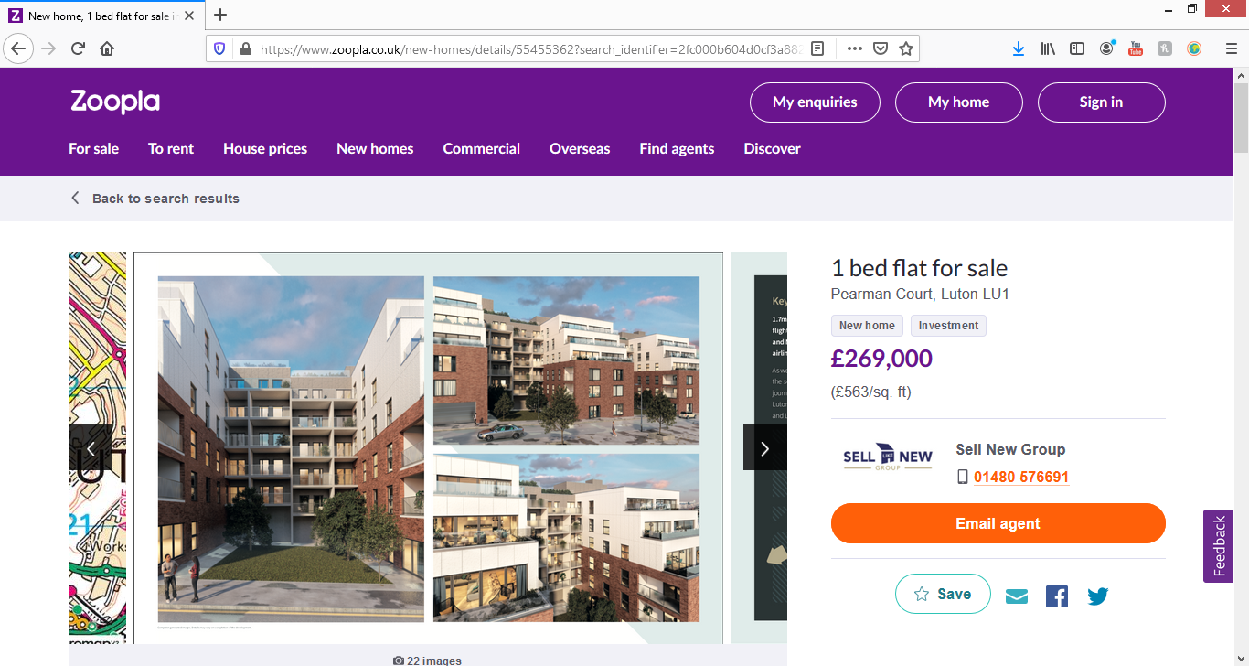
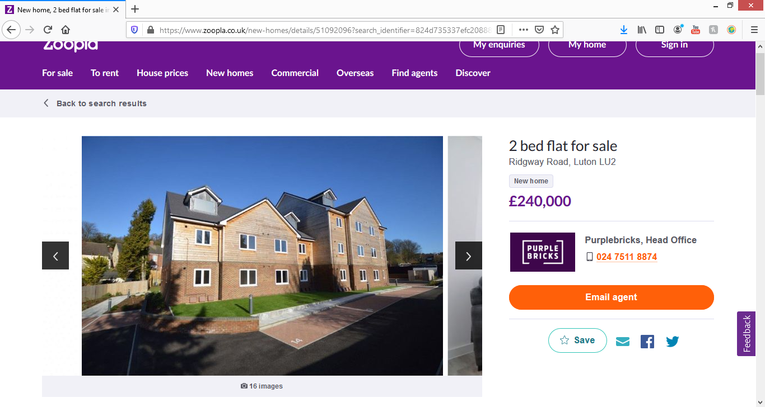
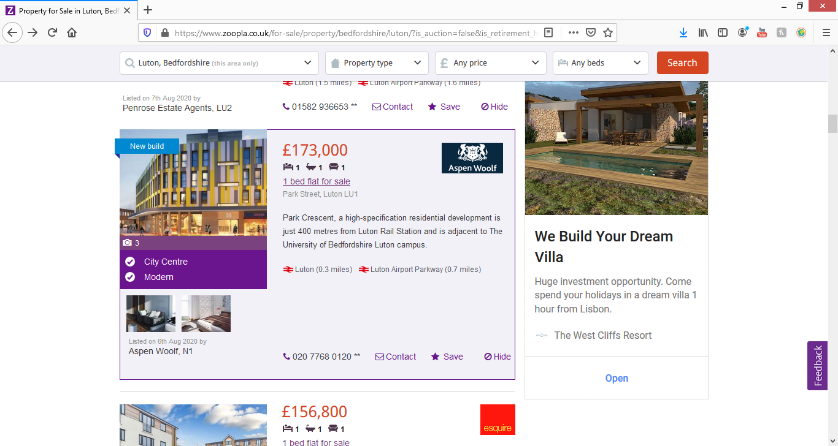

Description
Draft Details:
Pearman Court is an exciting new build development situated on Collingdon street in the heart of Luton arguably the best parts locations with the borough. It is located a very short walk away from The Galaxy, The Mall Shopping Centre, university campus and mainline train station, on the West side of the town. This iconic site is built by local building firm, Acre Estates, which offers 103 brand new contemporary, high specification 1,2 & 3 bedroom leasehold apartments, in varying sizes and layouts to suit different tastes and budgets. Excluding the ground floor all apartments will benefit from service lift access as well use of the communal stairs. The majority of apartments come with the added benefit of a private terrace or balcony, giving these units additional living space and identity, with views across the town and surrounding area. Each of the apartments comes with flooring included throughout and built in appliances to the kitchen including branded appliances such as aeg including ceramic hob, oven, extractor and washer/dryer. Furthermore, there is a phone audio and video entry system for added security. The development also offers a secure communal bike store and a communal bin store, all situated at ground level. All apartments are built to current build regulations for acoustic and thermal insulation and come with 10 year build warranty for extra piece of mind. It is estimated that the development will be completed by Spring 2020. Viewings are highly recommended to appreciate the quality of these homes and build.
The Location:
Pearman court is located on Collingdon street which is very well placed in the heart of Luton.

