Additional Properties Delivered in Luton Rapidly Continued 2b…
Date: 15 September 2020

CONTINUED… 2 B

https://www.zoopla.co.uk/new-homes/details/55062144?search_identifier=2fc000b604d0cf3a882ab3181e233969

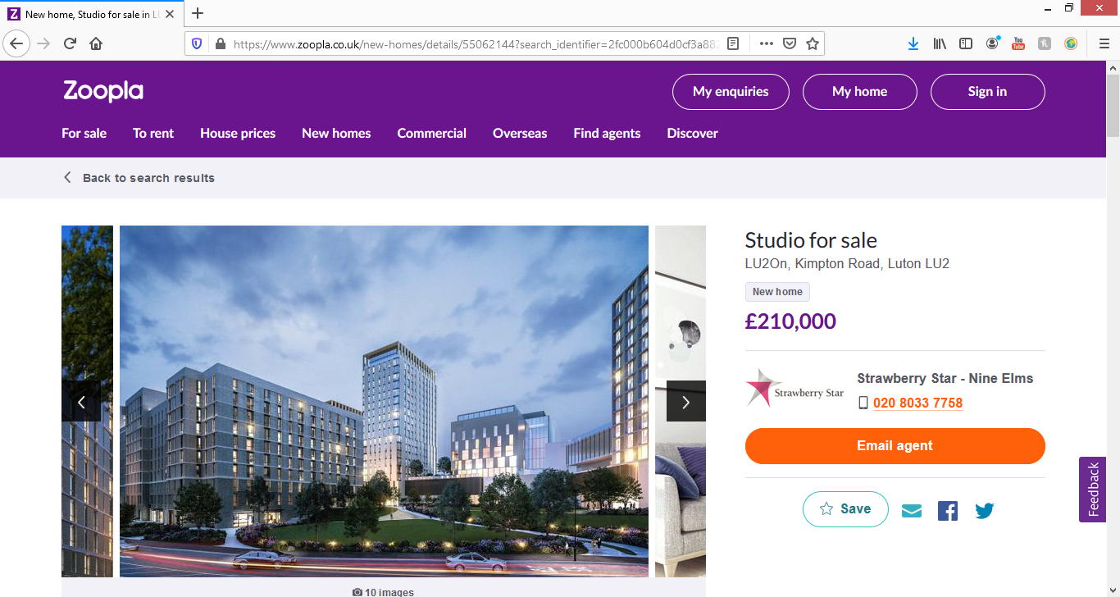

Studio for sale

LU2On, Kimpton Road, Luton LU2
- New home
£210,000

Description
Set across 6.9 acres, LU2ON is a perfectly located, exciting, new mixed-use development comprising of studios, one-bedroom and two-bedroom apartments. Residents will also enjoy an array of lifestyle amenities such as 24/7 concierge services, private communal gardens as well as access to shops, restaurants and an 8,000 sq. Ft state of the art gym.
Situated opposite to Luton Airport Parkway Station, London St. Pancras International is just 23 minutes away and direct connections can be found to Farringdon, Blackfriars and London Bridge.
The first phase of Lu2on, the Union building is estimated to complete in Q4 2021.
Show home:
Lu2on Show Home & Marketing Suite, Cubix Suite, 5th Floor
Hampton By Hilton, 42-50 Kimpton Road, Luton, LU2 0FP

https://www.zoopla.co.uk/new-homes/details/54076344?search_identifier=e2809764758b9ad48adfeffe2cee2c9d

1 bed flat for sale

58 Collingdon Street, Luton LU1
- New home
- Investment
£189,000
(£433/sq. ft)
Agent information View Agent profile

Sell New Group

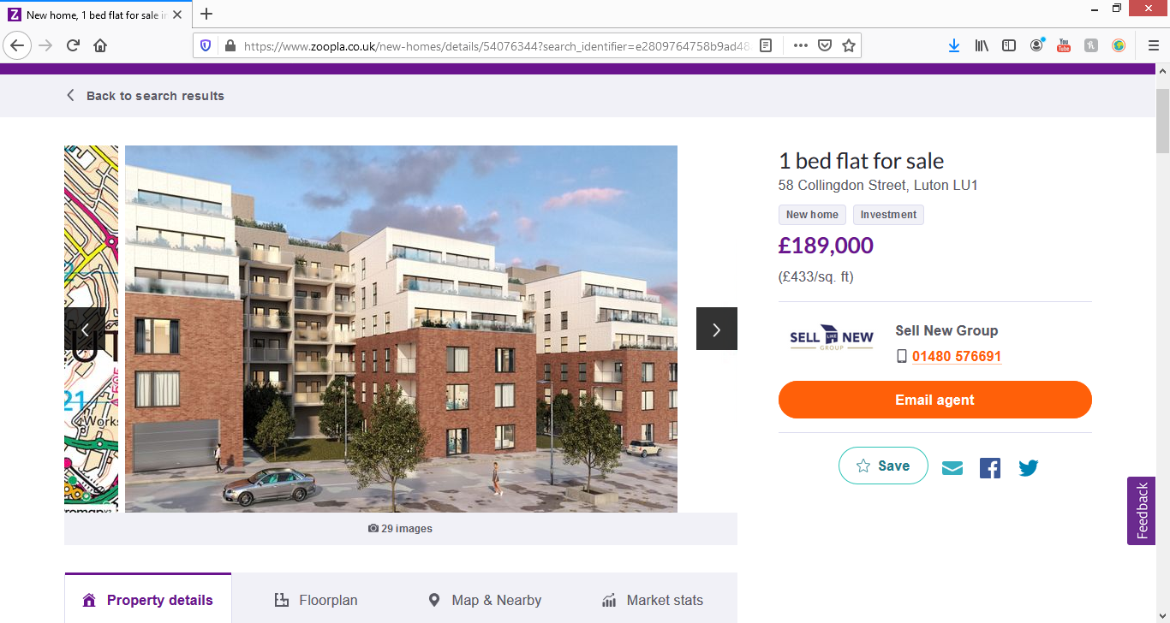

Description
Draft Details:
Pearman Court is an exciting new build development situated on Collingdon street in the heart of Luton arguably the best parts locations with the borough. It is located a very short walk away from The Galaxy, The Mall Shopping Centre, university campus and mainline train station, on the West side of the town. This iconic site is built by local building firm, Acre Estates, which offers 103 brand new contemporary, high specification 1,2 & 3 bedroom leasehold apartments, in varying sizes and layouts to suit different tastes and budgets. Excluding the ground floor all apartments will benefit from service lift access as well use of the communal stairs. The majority of apartments come with the added benefit of a private terrace or balcony, giving these units additional living space and identity, with views across the town and surrounding area.

https://www.zoopla.co.uk/new-homes/details/51522335?search_identifier=e2809764758b9ad48adfeffe2cee2c9d

1 bed flat for sale

South Road, Luton LU1
- New home
£160,000
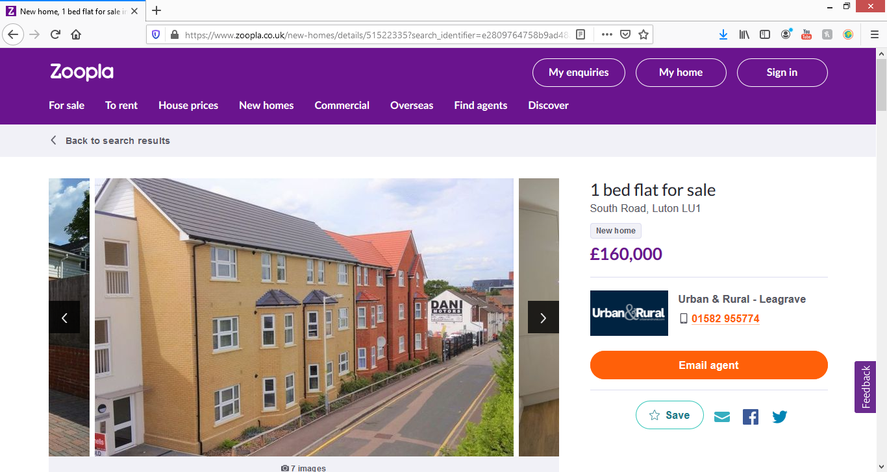

Description
** urban & rural * available now! * brand new luxury apartments**
Situated in the ever popular area of South Luton are these stunning luxury apartments with special features that comprise of; Code entry system, crl 10 year build warranty, quality kitchen with integral appliances, stunning bathroom, large bedroom and living area. Fantastic location to live due to being such a close distance to all travel links & local amenities. Help To Buy Available (subject to eligibility) EPC B

Links for this property
- 1 EPC image available
- Property Brochure
- Full Details
- See all residential properties for sale in Luton
- Report listing

Luton Developments
17 August at 15:52 ·
Newly converted apartments in Cardigan Street. From £190k
https://www.rightmove.co.uk/property…/property-72566379.html

1 bedroom apartment for sale in Cardigan Street, Luton £190,000. Marketed by Connells, Luton

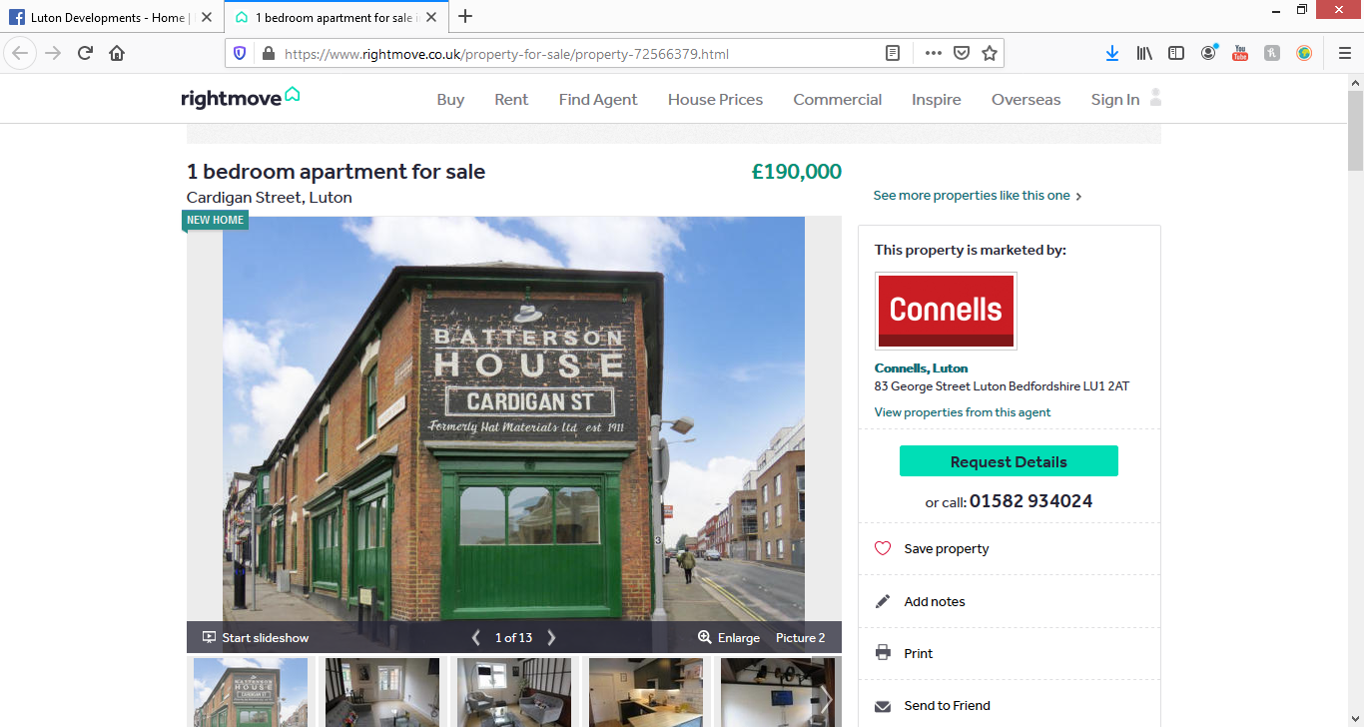Full description
Tenure: Leasehold
SUMMARY
JUST LAUNCHED - SHOW FLATS AVAILABLE… Batterson House offers 11 unique, luxury maisonettes and apartments, thoughtfully designed within this historic building located just outside of Luton Town Centre. Four show apartments are available to view now by appointment with Connells Luton.

rightmove.co.uk
Check out this property for sale on Rightmove!
1 bedroom apartment for sale in Cardigan Street, Luton £190,000.…

1 bedroom apartment for sale in Cardigan Street, Luton £190,000. Marketed by Connells, Luton

Top of Form
66
1 comment
LikeCommentShare

Comments
Most relevant

Matthew McGrath Looks brilliant. 👏🏼
  - 1d
Bottom of Form

http://dunstablenewsdesk.blogspot.com/2020/08/planning-news-fresh-plans-for-first-and.html?utm_source=dlvr.it&utm_medium=facebook

Planning News - Fresh Plans for First and Last Site
- 15.8.20

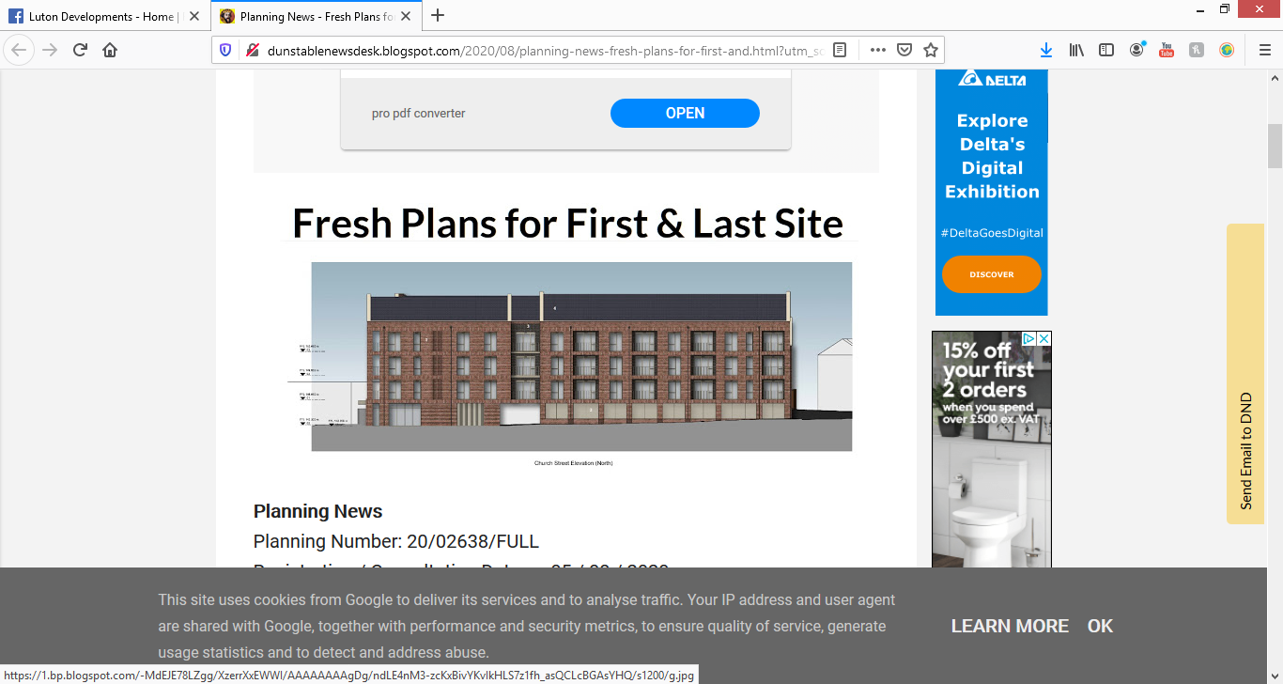
Planning News
Planning Number: 20/02638/FULL
Registration / Consultation Date: 05 / 08 / 2020
Earliest Decision Date (Consultation Period Expires): 09 / 09 / 2020
Target Date for Decision: 04 / 11 / 2020
Parish Name: Dunstable
Location: The First And Last, Church Street, Dunstable, LU5 4HP
Statutory Class: Small Scale Major Dwellings 10-199
Proposal: Erection of a new 3 part 4-storey residential building comprising 35 residential units and associated car parking, cycle parking, refuse storage and landscaping
View all documents: LINK
Submit a Public Comment Online: LINK

An entirely new plan has been drawn up for the former First and Last pub site in Church Street, Dunstable. In the new plan, no exit onto Church Street would be permitted, and two-way entry/exit traffic would be allowable onto St Peter's Road.

The new application represents an increase from 32 to 35 flats over the previous plan (CB/19/00830/FULL). The 35 flats would be arranged on three floors, in one block, facing onto Church Street, comprising and including 11 affordable housing units:
- 1B1P 3
- 1B2P 25
- 2B3P 4
- 2B4P 3
The proposal makes provision for 38 parking spaces (13 undercroft, 25 on site), including 2 disabled parking spaces, as well as 64 cycle parking spaces.

MIDLAND ROAD
https://www.optopropertygroup.com/projects/midland-road/
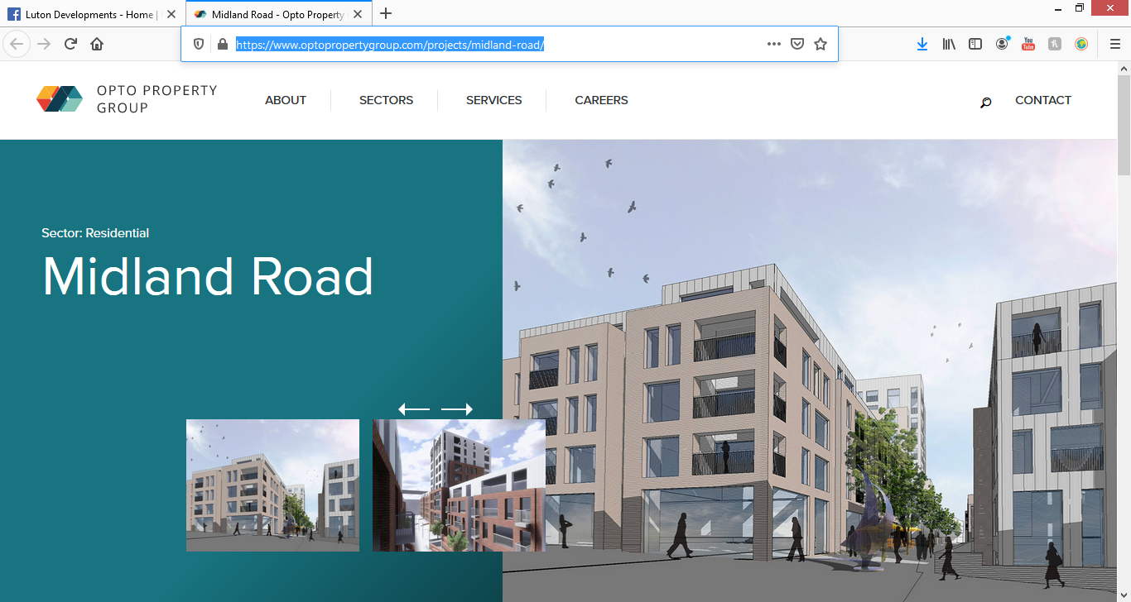

City centre living

Located in the heart of Luton, Midland Road is a new £40 residential and commercial project.
The residential part of the project will contain a selection of studio, 1 bed, 2 bed and 3 bed apartments with associated car parking.
Build with the rental market in mind, the development will appeal to locals and those who work and commute into London.
The project will be completed to an incredibly high standard and will appeal to today's demanding rental market.

Project details:
Client:
Midland Road Development Limited
Location:
Luton, United Kingdom
Value:
£40 million
Precurement:
Design and build
Quantity Surveyor:
WT Partnership
Size:
21,851 sqm
Completion:
Q1 2018

NEW BEDFORD HOUSE:
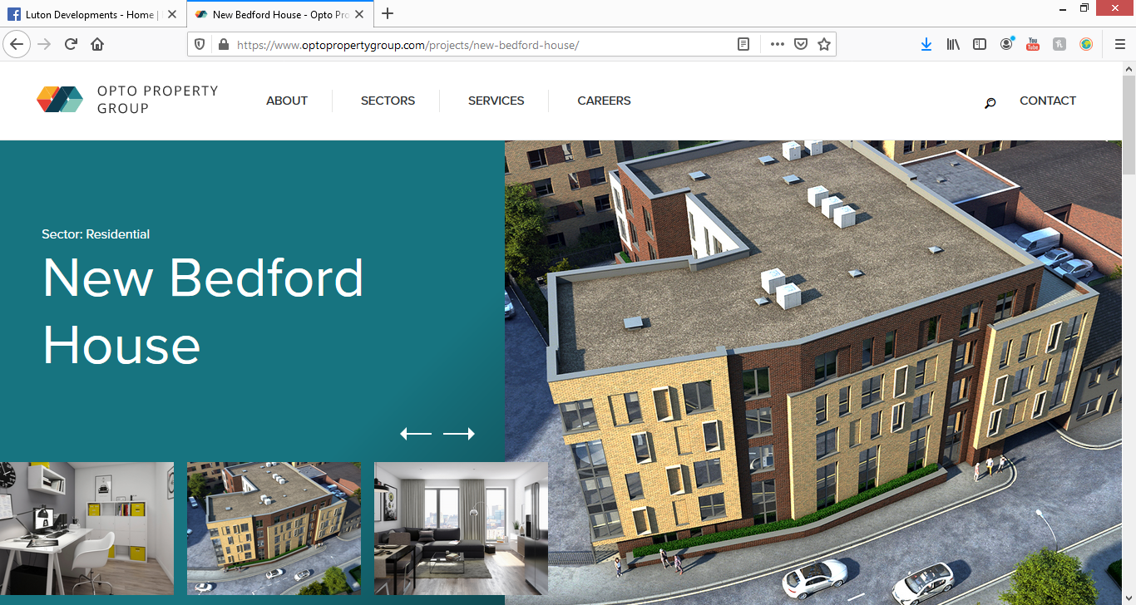

Residential property development in Luton

New Bedford House will be a new residential development that will contain 54 one and two bedroom apartments.
The £8 million project will be built with the rental market and mind and completed to a very high standard.
The location is ideal for the town's residential market and will provide much needed residential housing for the area.
Opto Property Group has carefully considered the local area throughout the design process and has designed something which will have a positive effect on the local community.

Project details:
Client:
New Bedford House Limited
Location:
Luton, United Kingdom
Value:
£8 million
Precurement:
Design and build
Quantity Surveyor:
WT Partnership
Size:
3,371 sqm
Completion:
Q1 2019

https://www.optopropertygroup.com/projects/new-bedford-house/

https://www.zoopla.co.uk/for-sale/details/53824550?search_identifier=e2809764758b9ad48adfeffe2cee2c9d

1 bed flat for sale

New Bedford House, Dudley Street, Town Centre LU2
- Investment
Guide price
£170,000
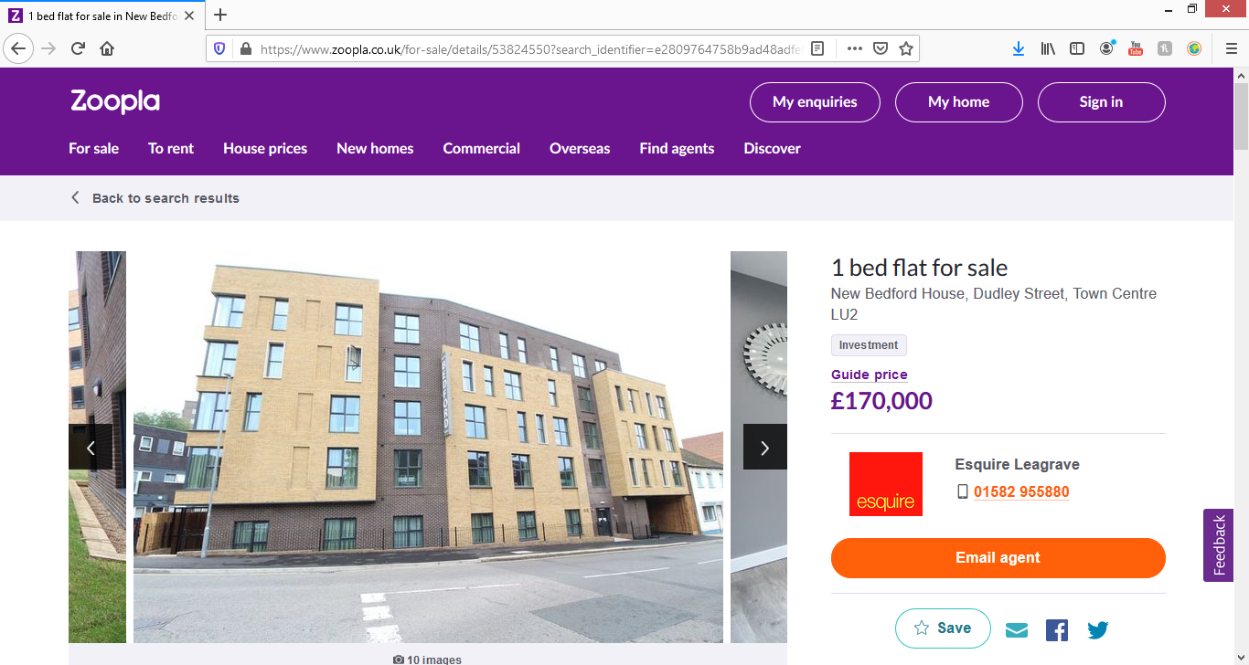

Description
Introducing this immaculate, fully furnished, new build second floor apartment located within walking distance to Luton's mainline train station (23 minutes into central London), The Mall shopping centre, the university of Bedfordshire and London Luton airport. The property comes with a three year guaranteed rent scheme which also pays for all management as well so makes an ideal investment purchase. The building comes with a 24 hour concierge service, lift to all floors, lovely communal garden area with a bike shed, automatic lighting and lovely roof terrace area. The flat itself briefly comprises of an entrance hall, large open plan lounge, kitchen and dining area, double bedroom and a modern bathroom. Must be viewed to fully appreciate, call us to book a viewing.

IMPERIAL SQUARE:
https://www.optopropertygroup.com/projects/flowers-way-luton/
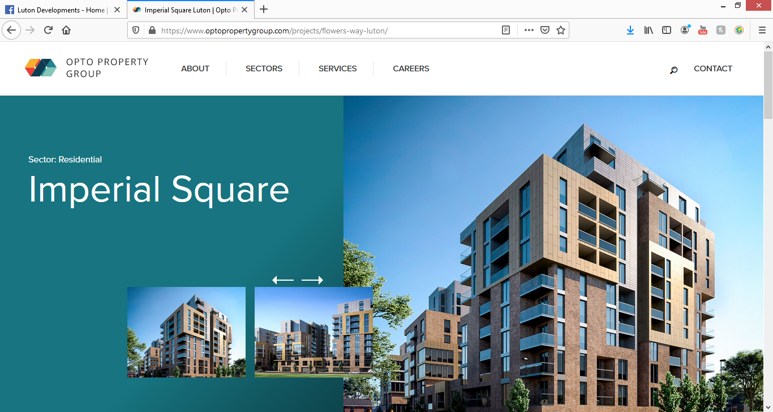

Contemporary new-build development

318 stylish 1 and 2 bedroom apartments
Opto Property Group will deliver a new-build development of 318 one and two bedroom apartments in Luton's town centre.
Imperial Square will be spread over three modern buildings and has been designed to address the shortage of housing in Luton and to cater to the rising number of city workers who are commuting into London from the town.

Project details:
Client:
Luton Residential Limited
Location:
Luton
Value:
£54 million
Quantity Surveyor:
WT Partnership
Size:
19036.8 sqm
Completion:
Q2 2020

CUMBERLAND STREET:
https://www.optopropertygroup.com/projects/cumberland-street/
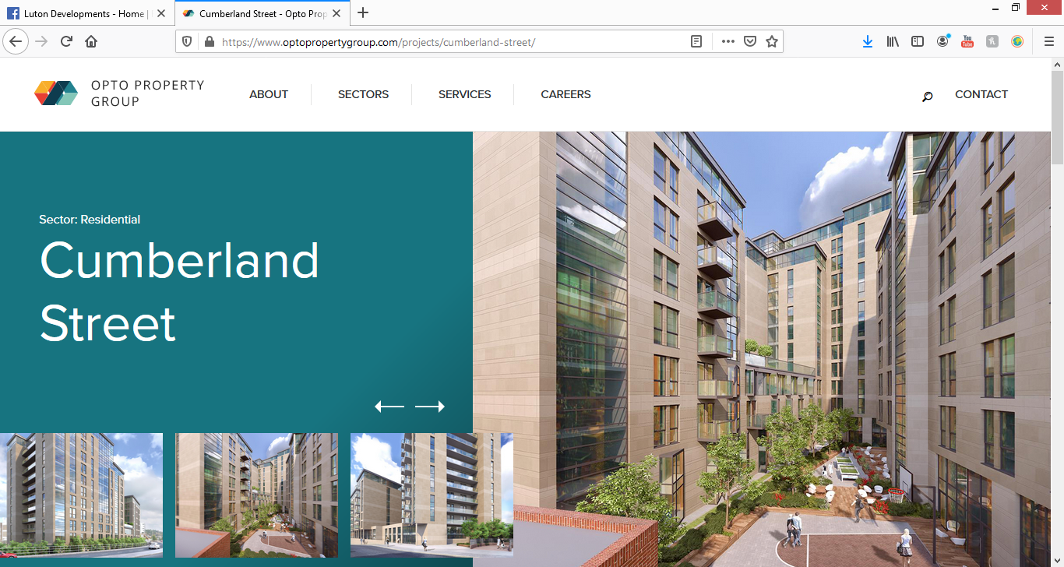

Cumberland Street, Luton

Opto Property Group has been appointed to oversee a new, £35 million mixed-use commercial and residential project named, Cumberland Place.
Located just a short walk from Luton town centre, the development will house a selection of modern, residential apartments which will appeal to the town’s buoyant rental market.
The central location of the property will appeal to the residential market and the apartments will be ideal for those commuting into London.
The site's location will also appeal to the commercial property market.

Project details:
Client:
Cumberland Street Development Limited
Location:
Luton, United Kingdom
Value:
£35.1 million
Precurement:
Design and build
Quantity Surveyor:
WT Partnership
Size:
143682.5 sqm
Completion:
Q2 2019

https://www.zoopla.co.uk/for-sale/details/52246640?search_identifier=e2809764758b9ad48adfeffe2cee2c9d

1 bed flat for sale

Flowers Way, Luton LU1
£158,270

Features
- Brand new development!
- -Intercom system
- Dish Washer
- Washing Machine
- -Programable Radiators
- Soft closing sliding doors
- 12 Hour Concierge Service
- 3 Months free Internet

Description
Brand new! Luxury - premium! Abbey Property Presents – very big flat located in the centre of Luton! 3 mins walk to train station and 1 min walk into town mall! The location couldn’t be any better! Integrated dishwasher, washing machine and fridge/freezer. Very spacious. This is not to be missed! Come in and have a look!

https://planning.luton.gov.uk/online-applications/applicationDetails.do?activeTab=documents&keyVal=QEWN8KKGIP800

Planning – Planning Application Documents
Help with this page (opens in a new window)
20/00995/FUL | Erection of a two storey building forming six apartments with parking and amenity space after demolition of existing office and storage buildings. | Builders Yard Rear Of 102 Icknield Road Luton LU3 2PA
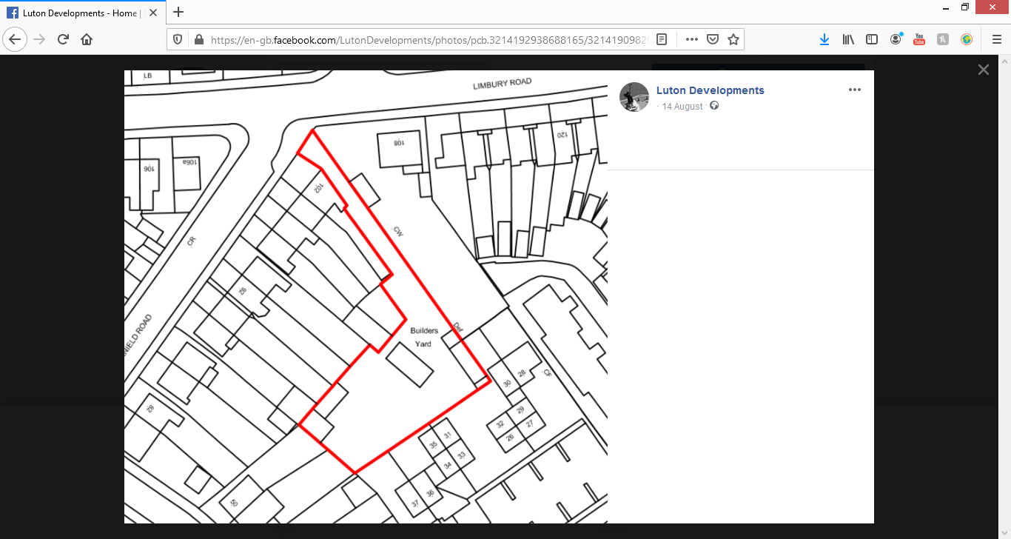

OAKLEY ROAD:

Luton Developments
12 August at 03:37 ·
New flats planned with shop units on High Street Leagrave.

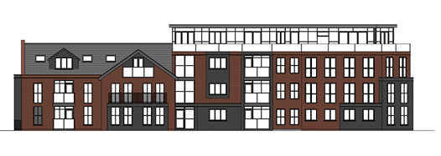

Luton Evolution
12 August at 02:46 ·
Plans for 40 flats and 3 commercial units at the junction of Oakley Road and High Street Leagrave.
The plans show 14 one-bed, 22 two-bed and 4 three bed flats, as well as car parking for 27 vehicles.
https://planning.luton.gov.uk/online…/applicationDetails.do

ABOVE MCDONALDS:

https://www.lutontoday.co.uk/news/people/planning-approval-ten-new-flats-lutons-mall-above-mcdonalds-and-church-2938363
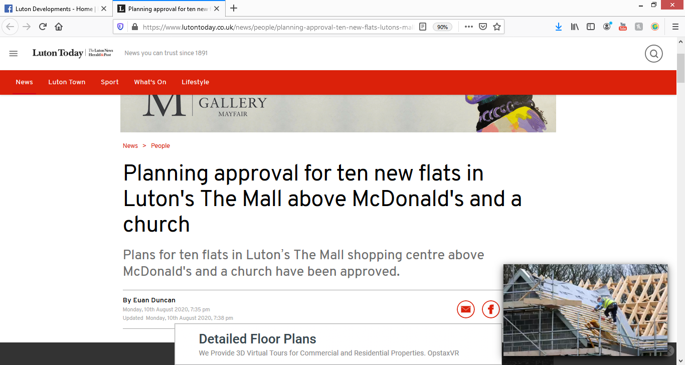
Applicant Pragma Homes Limited successfully resubmitted its scheme to convert the second floor of 46 George Street. It will be transformed with two one-bedroom, six two-bedroom and two three bedroom apartments.
The four-storey building houses McDonald's restaurant on the ground floor, Upperview Ministries Church on the first floor and also includes a basement, according to a report to the council’s development control committee.
The report stated: “It is located within a mixed use area of the town centre with a variety of commercial, leisure and residential uses.
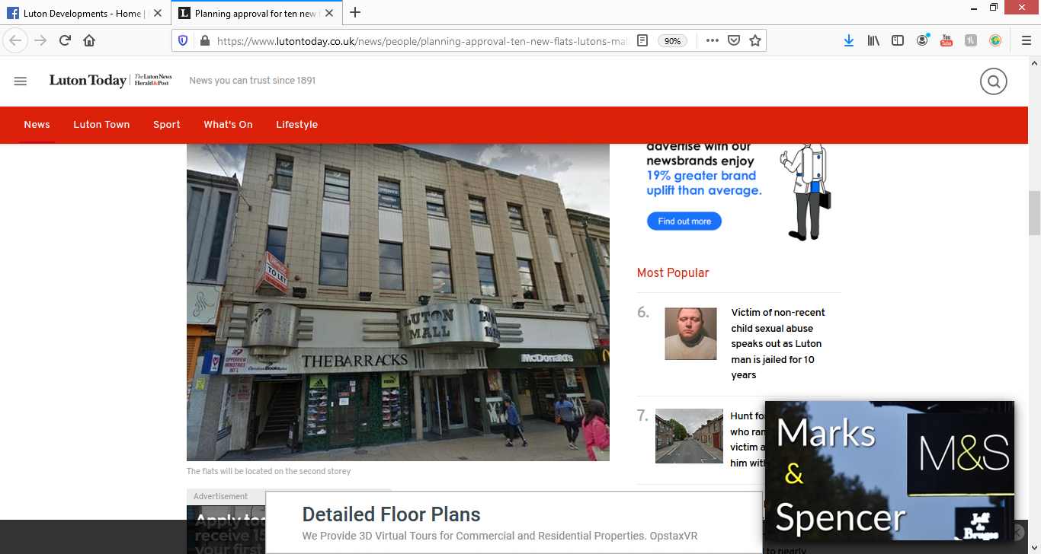
Plans to convert the second floor into 14 flats had been refused last December, according to the report.
“Officers consider the current project overcomes the three reasons for refusal,” it said.
“The large majority of the D1 floor space is now retained, and the small area that is lost is compensated for by a mixture of new D1 floor space and improvements to those facilities.
“The housing mix is more compliant, with nine out ten of the flats having two or three bedrooms.
“And the applicant agrees to the planning obligations required by planning policy.”
The main residential areas are in extensions at the back of the second and third floors in redundant former plant rooms, added the report.
These extensions will be partly rebuilt with a roof providing sufficient space to accommodate the size of flats proposed.

