Wallington Neighbourhood Plan 2022-2031
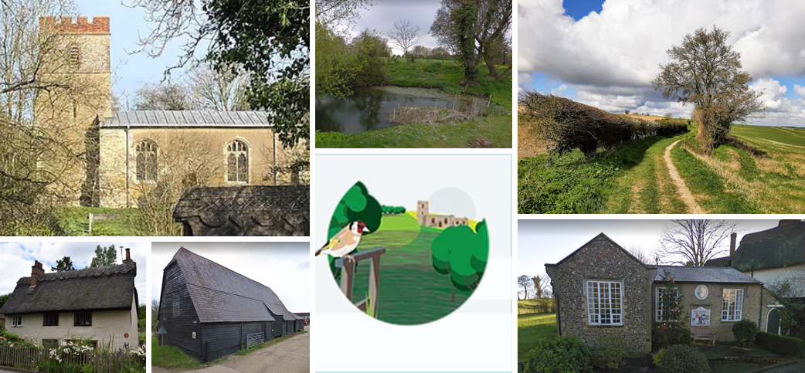
Neighbourhood Area Profile
Prepared May 2022, amended March 2023

TABLE OF CONTENTS
1. Introduction 3
2. Challenges and Opportunities for Wallington 5
3. Strategic Context 8
4. Detailed Statistics and trend data 15

Introduction

  - Wallington is a small Hertfordshire village located approximately three miles to the east of Baldock and roughly equidistant from Stevenage to the south west and Royston to the north east. It shares a parish council with neighbouring village, Rushden, but remains a separate parish.
  - The parish sits within some of the highest quality countryside in north Hertfordshire, comprising three landscape character areas: the Wallington Scarp slopes; the Weston–Green End Plateau; and the North Baldock Chalk uplands. Much of the parish is characterised by chalky boulder clay woodlands and meadows, which provide an important habitat for a range of species including the stone curlew, a national Red List species of bird, and the spotted fly-catcher. The far west of the area lies within Green Belt, protecting against coalescence with Baldock.
  - The parish is home to approximately 150 residents living in 54 dwellings. There is a village hall and playground, a church and a small triangular village green with well, and two further pond areas one adjacent to the junction of the Street and Church Lane and the second opposite to the church and sometimes known as Carter’s or Parson’s Pond ;; these community spaces enable a lively community scene, with a variety of activities and events taking place across the calendar. First recorded in Domesday as ‘Wallingtone’, the settlement has evolved from a predominantly agricultural base, with a number of working farms still operating today. The author George Orwell lived in a small cottage at no. 2 Kits Lane, then known as The Stores, in the village from 1936 to 1940. Orwell wrote his notable book Animal Farm in 1944, inspired by local landmarks, Bury Farm and The Great Barn.
  - The boundary of the village has changed little in the last century with very few new houses being built in recent decades. However, the housing stock has changed significantly from provision of farm labourers cottages to more substantial detached and semi-detached properties. This has been by way of transforming multiple smaller semi-detached and terraced cottages into more substantial single family homes.
  - The entire village and most of the farm buildings in and around Wallington Bury, to the south of the church, is located with in the Wallington Conservation Area, designated in 1969. The Church of St Mary is a Grade II Listed Building lying at the southern end of the village. The nave, west tower and windows date from the mid-15th Century. There are a further 18 nationally listed heritage assets as well as some locally important ones, such as The Old Post Office on The Street.
  - Wallington benefits from a network of footpaths and bridleways. The Icknield Way Path, noted as the oldest road in Britain, passes through the village on its 110-mile journey from Ivinghoe Beacon in Buckinghamshire to Knettishall Heath in Suffolk, as does the Hertfordshire Way one of the county’s more important walking and leisure routes.
  - To inform the emerging Neighbourhood Plan, it is helpful to prepare a detailed profile of the neighbourhood area. This profile includes statistical information about the local population, economy, housing and health. It also sets out the strategic planning context within which Wallington sits and findings from the community engagement to date, in order to set out the challenges and opportunities facing Wallington and how these might be addressed through the neighbourhood plan. This will provide the Working Group exploring the various topics with a starting point from which to gather additional evidence.
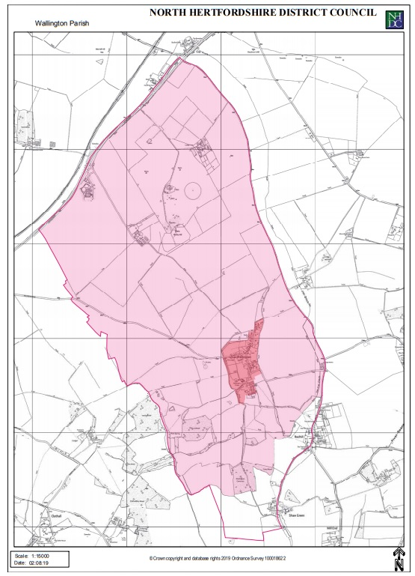
Figure 1.1: Neighbourhood Plan Area

Challenges and Opportunities for Wallington

- In October 2020, the local community was invited to submit their views on the parish in terms of what they liked and what might be improved. The findings are presented below.
Strengths – what is good?  - Rural Setting – beautiful scenery, peaceful, quiet, tranquil, accessible countryside, pretty, rustic.  - Sense of community - Quite sociable, coffee mornings, Village Hall events, friendly community.  - Generally low traffic.  - Wildlife friendly green spaces and features within the village boundary – pond, spinney, trees.  - Footpaths, good walks.  - Bus shelter.  - Friendly scale of the village, rustic charm.  - The village feels safe.  - Rich history - George Orwell, Church, churchyard.  - The character of the village – colours, materials.  - Grazing farm animals.  - Village Hall and play area as a focal point.  - Exclusivity of the village (house sizes and prices) | Weaknesses – What is not so good?  - Housing – cost; very few suitable properties available for young families  - No services.  - Isolated.  - Not much interaction from newer residents with existing residents.  - Poor maintenance of drainage by council.  - Traffic - being used as a rat run, lorries, speeding cars, A505 diversions, cars parked in the road.  - Poor transport links - no public transport. When we get older and can’t drive we can’t go anywhere.  - Dog poo, feral cats.  - Diversity of community.  - Newer developments looking out of character.  - Vandalism at Well Pond.  - Arkin?
Opportunities – what could we improve?  - More diverse population - It’s all good in Wallington but some new blood would make it even better; more young families/growing up children.  - More community involvement, e.g. helping with the fetes; more social events.  - Better local services – a shop, boulangerie,  - Less potholes on roads leading to village.  - Social housing/ affordable houses; housing to attract younger people and those from different socio-economic groups.  - More smaller homes, inc. for downsizers.  - Less litter.  - Ensure all new housing reflects local character – e.g. Wallington houses.  - Preference to develop brownfield sites/ convert barns.  - Volunteer-run shop.  - Opportunities for small industry/ business units (crafts?) in old farm buildings – also for homeworkers.  - Protection for our green spaces.  - Additional facilities - could we provide a bowls/tennis/social club/ petanque/ badminton/ table tennis?  - Enhance wildlife conservation.  - Opportunities for additional parking, e.g. at the farm area. | Threats – what do we need to look out for?  - Traffic and rat-running will worsen as a result of surrounding developments.  - Impact of (mass) development nearby.  - Development overpowering the village – prefer smaller developments.  - Affordable housing not truly affordable.  - Erosion of character.  - Infill development.  - Loss of special views.  - Intrusion on privacy.  - Lack of infrastructure – mobile service.  - Lack of homes for those with a connection to the village.  - Noise associated with business units.  - Need to ensure we involve teenagers.  - Involvement from those not living in the village in the Working Group.  - Social housing.

  - Section 4 of this report contains detailed statistics about the area.

Strategic Context

National Planning Policy
- The policies of the Neighbourhood Plan will need to be in general conformity with the National Planning Policy Framework (NPPF), which was most recently revised in July 2021. This states the following about Neighbourhood Planning at paragraphs 29 and 30:
“Neighbourhood planning gives communities the power to develop a shared vision for their area. Neighbourhood plans can shape, direct and help to deliver sustainable development, by influencing local planning decisions as part of the statutory development plan. Neighbourhood plans should not promote less development than set out in the strategic policies for the area, or undermine those strategic policies.

Once a neighbourhood plan has been brought into force, the policies it contains take precedence over existing non-strategic policies in a local plan covering the neighbourhood area, where they are in conflict; unless they are superseded by strategic or non-strategic policies that are adopted subsequently.”

Local Planning Policy

- Wallington falls within the North Hertfordshire District Council (NHDC) area and all Neighbourhood Plan policies must be in general conformity with its strategic planning policies. The current Development Plan for NHDC consists of the following documents:
- North Hertfordshire Local Plan 2011 to 2031 (adopted November 2022)
- The Waste Site Allocations Development Plan Document 2011-2026 (adopted July 2014)
- The Waste Core Strategy & Development Management Policies Development Plan Document 2011-2026 (adopted November 2012)
- The Minerals Local Plan 2002-2016 (adopted March 2007)
- Made Neighbourhood Plans in the District
- The adopted documents are also supported by the following Supplementary Planning Documents:
- The Employment Land Areas of Search Supplementary Planning Document (adopted November 2015)
- The Minerals Consultation Areas Supplementary Planning Document (adopted November 2007)
The Local Plan
- Policy SP2 (Settlement Hierarchy and Spatial Distribution) of the emerging Local Plan seeks to deliver a minimum of 11,500 net new homes, and at least 30.5ha of B-class employment space and associated sui-generis uses, across the District over the period 2011 to 2031. Approximately 80% of housing delivery is proposed to be focussed to the larger settlements, 11% to villages identified for growth, and the remainder to smaller villages.
- Wallington falls within this 11% and is classified as a Category B village in the Local Plan, where limited infilling development, which does not extend the built core of the village, will be supported. This is a new categorisation for Wallington and the implications of this on housing development in the village are not yet known. It is one of the reasons why this neighbourhood plan is essential at this time. There are no sites allocated in the emerging local plan for Wallington. Two new homes have been built or granted planning permission since 2011.
- The Neighbourhood Plan began development prior to the adoption of the Local Plan. At the start of the process, the emerging Local Plan policies were considered so that the scope of the Neighbourhood Plan could be considered.
- A copy of the initial opportunities based on that early analysis is recorded below. As the Local Plan has now been adopted, the Neighbourhood Plan policies have been reviewed accordingly to ensure that they align.
Opportunities for the Neighbourhood Plan – early scoping exercise
Emerging Local Plan  Policy | What it seeks to achieve | Scope for Wallington Neighbourhood Plan | Relevant evidence
SP2: Settlement Hierarchy | The emerging Local Plan seeks to identify Wallington as a Category B village and Infilling development which does not extend the built core of the village will be allowed.  The Local Plan does not, however, define a settlement boundary or the extent of the built core. The Council believes it should be possible to assess on a case-by-case basis whether a site is in the built core. However, that may be something that affected communities wish to explore through neighbourhood plans. | - To set out a localised Spatial Strategy setting out where the ‘built core’ of Wallington is. Within this area, limited infill would be feasible (potentially to include the farm site/s). | - Design Codes/ Character Study.  - Estimated population: 118 in 2031 (down from 159 in 2001)  - Aging population so a need to consider the impacts on design and provision of local facilities.  - Also note changing ways in working (e.g. more remote) combined with Fibre Broadband now introduced to the village. This has made a significant difference to the existing residents but will also make Wallington much more attractive to prospective house buyers, particularly those of a working age and with children.
SP3: Employment | Focuses activity to the larger settlements and strategic allocations.  ETC2 safeguards existing employment unless certain criteria are met.  ETC8 supports tourism-related development in rural areas, where a case can be made. | - Scope to consider what could assist existing employment in the area, including home workers.  - Is there a need/support for tourism-related activity locally? | - Local survey feedback.
SP4: Towns and Local Centres | Supports the retention and provision of shops outside of identified centres where they serve a local need.  ETC7 sets out criteria in more rural areas. | - Identify any facilities or shops to continue to support and/or consider any facilities that might be needed.  - Identify if any of the public houses or other local facilities might be listed as an Asset of Community Value. | - Local survey feedback.  - Could a local shop be supported or subsidised?  - Would a community pub owned and run by the residents be a commercially viable option (Moon & Stars being a community asset)
SP5: Countryside and Green Belt | Retaining Green Belt and its purposes (where amendments have not been identified) and operating a general policy of restraint in Rural Areas beyond the Green Belt. This recognises the fact that, in terms of intrinsic character and beauty, the rural area contains some of the highest quality countryside in the District.  CGB1 allows infill within the ‘built core’.  CGB2 sets out broad criteria for Exception Sites.  CGB3 supports rural worker’s dwellings.  CGB4 allows for the re-use, replacement or extension of rural buildings. | - The Neighbourhood Plan could consider mapping its Green Infrastructure network and features of the countryside that are typical of the area and should be protected.  - It should seek to ensure a net gain in biodiversity.  - It could also identify Local Green Spaces.  - Define the ‘built core’ for Wallington.  - Can you expand on the criteria for Exception Sites, to make it more locally specific? | - Survey of potential Local Green Spaces.  - Green Infrastructure Plan.  - Design Codes/ Character Study.
SP6: Sustainable Transport | Protecting Rights of Way and encouraging sustainable modes of transport | - Measures to support non-polluting modes of transport.  - Linkages and improvements to the Prow network.  - Public transport – the weekly bus service was withdrawn several years ago.  Do we need to include requirement for in plan or consider car sharing schemes? | - Map our Prow network and set out where improvements needed.  - Opportunities for improved parking access to properties, which could be designed to reflect the rural character of the area, avoiding extensive use of modern brick retaining walls, reducing hard surfacing and ensuring visibility splays are in character with surrounding property boundary treatments.
SP8: Housing | A need to deliver 14,000 homes between 2011 and 2031.  HS1: No target provided for Wallington.  HS2: Sets out Affordable Housing criteria.  HS3: Housing Mix expectations | - One home has been delivered in the area since 2011. This could link to the Spatial Strategy and a policy setting out design criteria for any windfall.  - Do we want to set out how affordable housing/ housing mix relates to the area – based on findings of the Local Housing Needs Survey. | - Housing Needs Assessment.  - Housing Needs Survey.
SP9: Design and sustainability | Good design being integral to sustainable development.  D1: sets out specific criteria | - An opportunity to set out what is meant by ‘local context’ in Wallington, in order to provide design and character criteria for any new development proposals. This will take its detail from the Character/Design work being undertaken. | - Design Codes/ Character Study.  - Reintroduction of long-straw thatching for roof replacement when the need arrives
SP10: Healthy Communities | Supporting existing and new facilities to support healthy, inclusive communities, including green spaces.  HC1: sets out the need to deliver against an identified community need | - Potential to identify existing facilities that should be safeguarded and opportunities to enhance these.  - Identify potential Assets of Community Value. | - Local survey feedback.  - In the last few years c. £10k has been spent on new play equipment. Also the Village Hall windows and heating have been replaced and the hall completely redecorated.
SP11: Natural Resources and Sustainability | Addressing the challenges of climate change. | - Consider any localised issues that need to be tackled e.g. flooding | - Local survey feedback.  - Flooding is now a recurring issue, exacerbated by poor drainage
SP12: Green Infrastructure, biodiversity and landscape | Protecting, enhancing and managing green infrastructure.  NE4: Protects public open space.  NE6: New and improved open green space. | - Map out the Green Infrastructure network locally. Are there any deficiencies set out in the North Hertfordshire District Green Infrastructure Plan  - Opportunity to identify important public open space in the area – see Open Space Review.  - Designate Local Green Spaces.  - Identify locally significant views. | - North Hertfordshire District Green Infrastructure Plan.  - Local survey to identify Local Green Spaces – e.g. Wallington Common.  - Open Space Review - is there sufficient space by category?  - Hertfordshire ecological networks mapping report –available on request from the Herts Environmental Records Centre http://www.hercinfo.org.uk/  - Conservation Statement
SP13: Historic Environment | Protect and enhance historic assets.  HE1: Designated heritage assets.  HE2: Heritage at Risk.  HE3: Local Heritage. | - Consider any non-designated heritage assets in the area.  - Also heritage assets at risk.  - Set out more detailed proposals around character and design. | - Heritage Assessments – there is not one for Wallington – will be explored as part of Design/Character work.  - Heritage Gateway.  - Local survey feedback.

Detailed Statistics and trend data

  - The following sub-sections set out the detailed statistics and trend data for the neighbourhood area. Unless otherwise specified, data is taken from the 2011 census, which although some years old now, is considered to be proportionate for this purpose. It should also be noted that data has been taken for Wallington parish, which extends slightly beyond the neighbourhood area.
  - Some 2021 census is now available, and this has been included under each section.
Population
  - The 2011 Census recorded that the usual population of the parish was 150 persons and 60 household spaces, of which 56 were usually occupied. The population of North Herts district as a whole is 127,144, therefore the parish of Wallington represents less than 1% of the overall population of the district.
  - Figure 1 below shows the age breakdown of the population in 2011.

Figure 1: Age profile of Wallington residents, 2011
  - It is interesting to consider how the population is evolving and Figure 2 reveals the change in age profile of the population between 2001 and 2011.

Figure 2: Change in age profile of Wallington residents, 2001 to 2011
  - Over the ten-year period between 2001 and 2011, the population of the area fell from 157 residents to 150.
  - It will be interesting to consider how these trends have changed since the 2011 census and an important exercise will be to update the statistics once the 2021 census data is made publicly available.
2021 Census Update
  - The number of residents has again fallen, to 140 people. The age profile is shown in Figure 2a. Families still appear to be within the Parish, but the predominant shift is to the older age brackets.
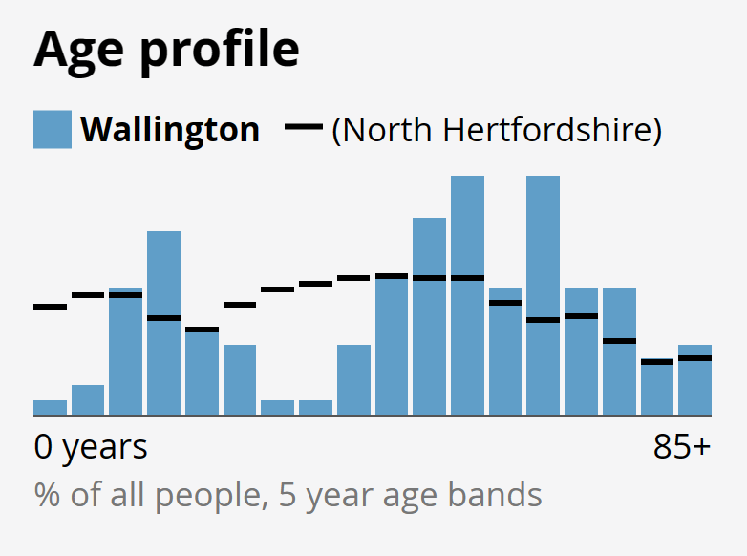
Figure 2a: 2021 age profile

Housing

Current house prices
  - The area is very rural with most of the housing located within Wallington village itself. There have been no large-scale developments in recent years and it would appear that families living in the area remain in situ, with few new, younger couples and families moving in. It is interesting to consider the impact that house prices have on this both locally and on a wider geographical basis.
  - A comparison of house price sales in nearby settlements, by type and value between (April 2019 to April 2020, www.rightmove.com) is provided below:
- Baldock: The majority of sales were terraced properties, selling for an average price of £319,581. Semi-detached properties sold for an average of £340,618, with flats fetching £171,211. The average of all property types was £303,746 (2,830 sold).
- Royston: The majority of sales were terraced properties, selling for an average price of £293,351. Detached properties sold for an average of £620,073, with flats fetching £173,413. The average of all property types was £375,000 (4,847 sold).
- Sandon: The majority of sales were detached properties, selling for an average price of £678,000. Terraced properties sold for an average of £360,000.The average of all property types was £519,000 (77 sold).
Compared to the other locations, on the whole houses in Wallington for sale are few and far between. They are also more expensive, inevitably, than those available in the larger settlements. Almost all sales were of detached homes.
Dwelling type
  - There were 56 occupied household spaces in the parish in 2011 and Figure 3 breaks these down by type. The vast majority of homes are detached, much higher than for North Herts and the East region as a while, which mirrors the findings on the house prices. Council tax bands are therefore likely to be higher too. There are no terraced properties or flats in the area.

Figure 3 – Type of housing in the Area
2021 Census Update
  - The 2021 census records 6 households in the Parish.

Number of bedrooms
  - Figure 4 sets out the proportion of occupied dwellings by number of bedrooms in Wallington and respective geographies. As might be expected in an area with higher levels of detached and semi-detached properties, Wallington has a significant proportion of homes with 3 or 4+ bedrooms (c52%) compared to the borough and wider region.
  - On the other hand, the proportion of 2-bedroom properties is significantly lower (c9%) than comparative geographies as are 1-bedroom dwellings, which account for just 1% of Wallington’s homes. The dwelling sizes in the parish are weighted toward the larger dwelling size in comparison to the wider geographies.

Figure 4: Household dwellings by number of bedrooms
2021 Census Update
  - Figure 4a shows the number of bedrooms in the 2021 census:
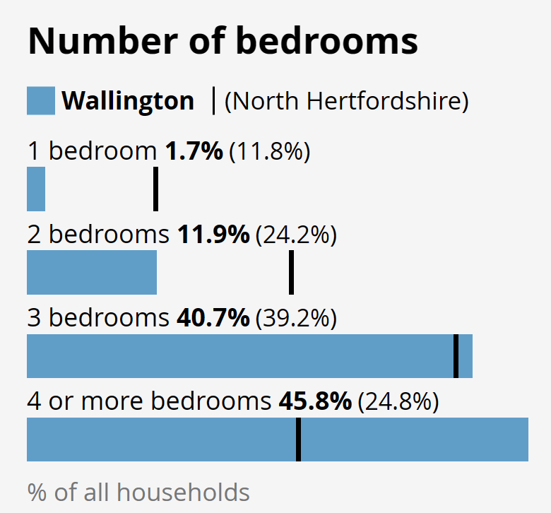
Figure 4a: Number of bedrooms (2021)

Tenure
  - The tenure of housing refers to the legal status of the occupier in relation to the property in which they live. The key tenures for the purpose of this analysis are:
Owner occupier | Where the occupier owns the property on a freehold or long leasehold basis with or without a mortgage.
Private rent | Where the tenant rents the property from a private individual or organisation usually at a rent dictated by market conditions, but in any event free from statutory or other regulatory rent controls.
Affordable housing for rent | Where the tenant rents the property from a registered provider of social housing (Registered Provider) and the property is let at a below market level rent and controlled by statute or other regulatory power. A Registered Provider is usually a local authority landlord or housing association.
Affordable housing for sale | Where the occupier owns or part owns the property and has received some form of subsidy in order to do so. The property will usually be bound by some form of condition or covenant that ensures that the subsidy remains vested in the property.

  - The tenure of housing is illustrated in Figure 5, revealing that the area predominantly comprises homes that are owned by their occupants, either outright or with a mortgage. The number of social rented housing available is extremely low, although private rented property availability is comparatively higher than across the district and wider area.

Figure 5: Tenure of housing
  - Figure 6 shows the tenure change over the period 2001 to 2011. Whilst the number of properties in Wallington grew by only 2, there has been a shift in the tenures of homes overall. Significantly, the number of homes rented from the local authority has diminished – in reality this was 3 homes in 2001 down to 1 home in 2011. The number of such homes across the district fell dramatically too, perhaps explained by the selling off of stock to housing associations. There was an increase of 1 social rented (non-local authority) in the same period in Wallington. Privately renting opportunities have also increased modestly and in line with the district.

Figure 6: Tenure change between 2001 and 2011

2021 Census Update
  - Figure 6a shows the tenure situation in the 2021 census:
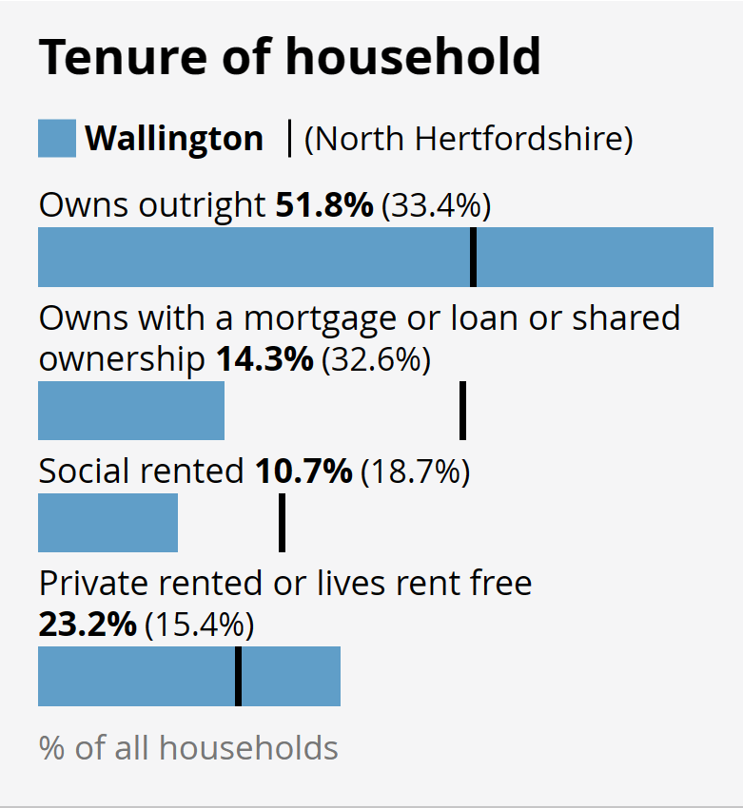
Figure 6b: Tenure in 2021

Household composition
  - Household composition is a fundamental factor driving the size of housing needed in the parish in the future. Figure 7 sets out the household composition by age in Wallington compared to the district and wider region. Whilst the majority of homes house a family, 34% of these do not include children. Just under one fifth of homes are occupied by a single person; given that the majority of homes in the parish are larger, detached properties this would suggest that such houses are under-occupied.
 |  | Wallington | North Herts | East
One person household | Total | 18% | 29% | 28%
Of which: | Aged 65 and over | 5% | 13% | 13%
 | Other | 13% | 16% | 16%
One family only | Total | 77% | 66% | 65%
Of which: | All aged 65 and over | 14% | 9% | 9%
 | With no children | 20% | 13% | 13%
 | With dependent children | 27% | 28% | 27%
 | All children non-dependent | 11% | 9% | 10%
Other household types | Total | 5% | 5% | 6%
Figure 7: Household composition by age
Household occupancy rates
  - There were 56 households (occupied) in Wallington and 150 usual residents. This means that the average number of people living in a dwelling was 2.7, marginally higher than for the district and region (both 2.4).
  - Whilst the average occupancy levels are marginally higher than the borough and regional average, it is helpful to drill down further to explore the extent to which households are either over- or under-occupied. Occupancy rating provides a measure of whether a household's accommodation is overcrowded or under occupied. There are two measures of occupancy rating, one based on the number of rooms in a household's accommodation, and one based on the number of bedrooms. The ages of the household members and their relationships to each other are used to derive the number of rooms/bedrooms they require, based on a standard formula. The number of rooms/bedrooms required is subtracted from the number of rooms/bedrooms in the household's accommodation to obtain the occupancy rating. An occupancy rating of -1 implies that a household has one fewer room/bedroom than required, whereas +1 implies that they have one more room/bedroom than the standard requirement.
  - Over-occupation may occur where there are a larger number of people living in a dwelling with a smaller number of rooms and vice versa for under-occupation. Over-occupation can lead to detrimental living conditions and is therefore not desirable. On the other hand, while under-occupancy might suggest that housing is effectively tied-up and not available for growing or extended families, many people choose to remain in their larger family home when their children move out, in order to retain that property for space, value or sentimental purposes. If however, the reasons for under-occupation is because there are insufficient local properties to downsize to, then this can indicate a challenge that can be addressed via the planning system.
  - Figure 8 shows the percentage of dwellings in Wallington and the wider geographies that are either under- or over-occupied, in the context of number of bedrooms.
  - For Wallington, the data reveals that 66% of dwellings in the parish are under-occupied by 2 bedrooms or more. This is significantly higher than the data for the district and wider region, but is perhaps not surprising given the number of larger properties in the parish compared to smaller ones.

Figure 8: Percentages of properties either over- or under-occupied
2021 Census Update
  - Figure 8a shows the occupancy situation in the 2021 census:

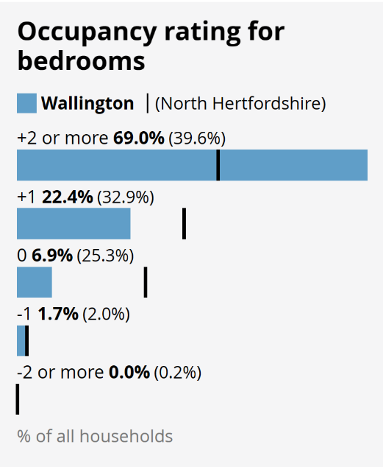 Figure 8a: Occupancy 2021

Work and skills

Type of employment
  - Of the residents in the area who were aged between 16 and 74 years old, 77% are classified as economically active. The remaining 23% are economically inactive and 58% of these are retired. The remaining economically inactive include 19% who are full time students and 15% who are looking after a family member full time.
  - Figure 9 illustrates the breakdown of how people are employed. Whilst the majority of those who are economically active work as an employee, there is a significant number of people who are self-employed (29% compared to 15% across the borough area). Self-employed people can often be more likely to work from home, therefore highlighting the need to ensure that the facilities and infrastructure – e.g. broadband and mobile connectivity and speed – is in place. The Covid-19 pandemic in turn has potentially led to more employees also working from home.

Figure 9: Economic activity (Retired is shown as a percentage of non-economically active)
Method of travel to work and distance
  - Understanding how people reach their place of work is helpful when considering the potential impact that commuting has on the local transport infrastructure. Figure 10 suggests that of those residents in employment, 71% are commuting by car to their place of work. This is perhaps unsurprising in a rural area, where the main source of employment is likely to be in the nearby major towns and cities. A higher-than-average number of people work from home, which is also perhaps unsurprisingly given the number of self-employed people.

Figure 10: Mode of transport to work

2021 Census Update
  - Figure 10a shows the mode of transport taken to work recorded in the 2021 census:

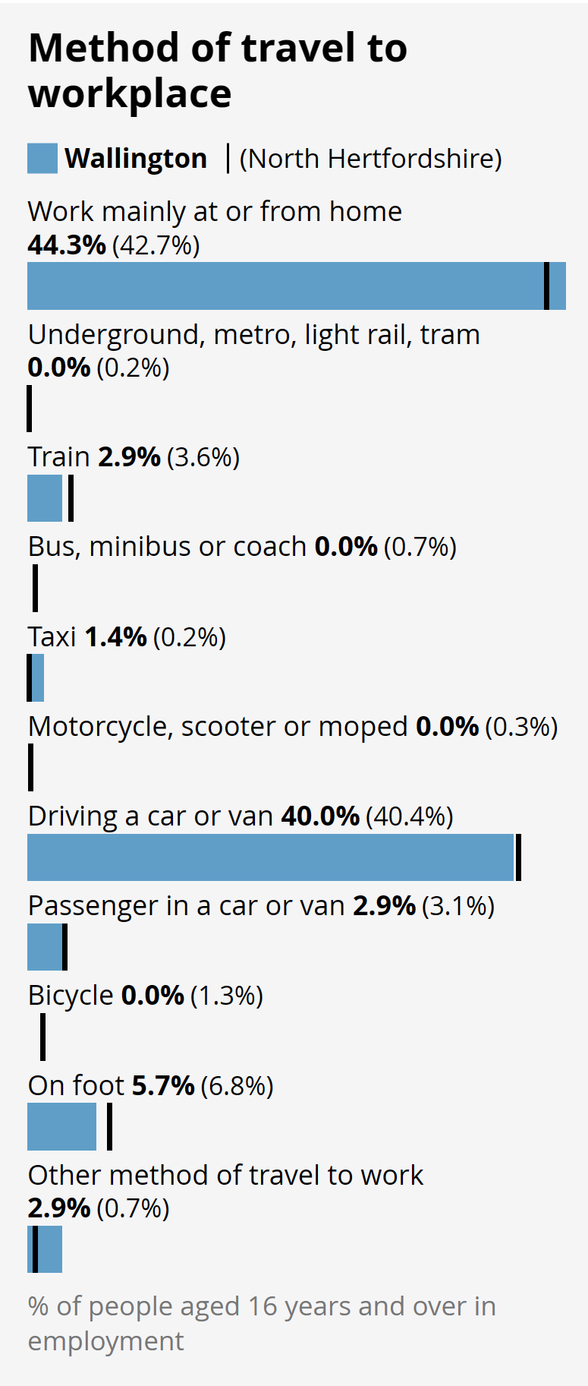
Figure 10a: Mode of transport to work, 2021

  - Figure 11 indicates how far people are travelling to reach their place of work. Of those commuting to work, 43% are travelling at least 10km to reach their place of work, which would include:
- 10km: Stevenage, Letchworth, Royston.
- 20km: Hertford
- 30km: Luton and Cambridge
- 40km: Milton Keynes
- 50 to 60km: London

Figure 11: Distance travelled to place of work
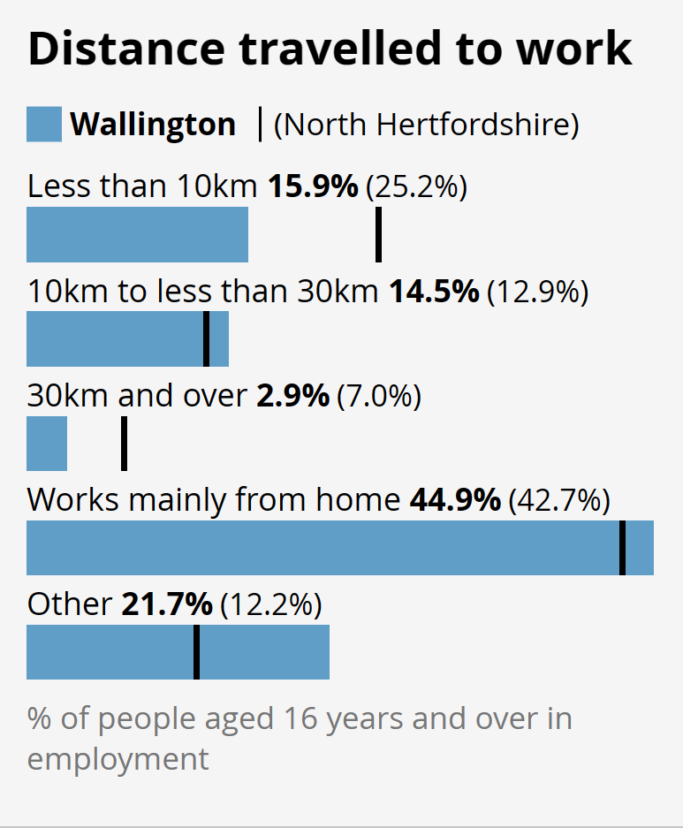
Figure 11a: Distance travelled to place of work (2021)

  - No households in the area are without access to a car (Figure 12), implying that car usage is high. There is a need to consider how to encourage shorter journeys to take place by other means. This is supported by the significantly higher numbers of households than average having at least 3 cars (in all likelihood driven by the fact that many households have older children still living at home), when compared to the broader geographic area.

Figure 12: Number of cars per household

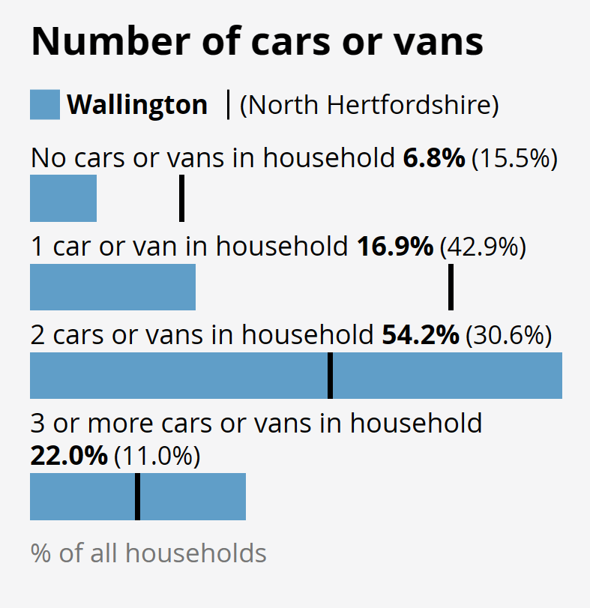
Figure 12a: Number of cars per household (2021)

  - Figure 13 shows the qualifications of the local residents aged 16 years and over. Wallington has a well-qualified local population, reflected in the low levels of unemployment.

Figure 13: Highest level of qualifications

Health
  - Residents in the Area enjoy a good level of health overall, mirroring the borough as a whole, as illustrated in Figure 14.

Figure 14: Level of health

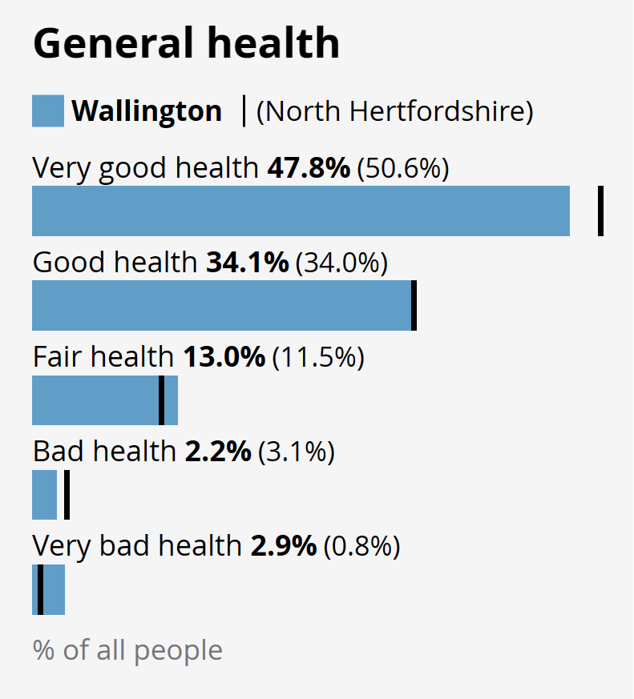
Figure 14a: Level of health (2021)

Neighbourhood plans must be in general conformity with the strategic policies contained in any development plan that covers their area.
https://www.north-herts.gov.uk/sites/northherts-cms/files/OSC4%20North%20Hertfordshire%20Open%20Space%20Review%20%26%20Standards%202016.pdf
https://www.north-herts.gov.uk/sites/northherts-cms/files/Wallington%20CA%20Character%20Statement.pdf

