North Hertfordshire Local Plan Preferred Options 2011 – 2031
A Guide to Viewing Representations Online
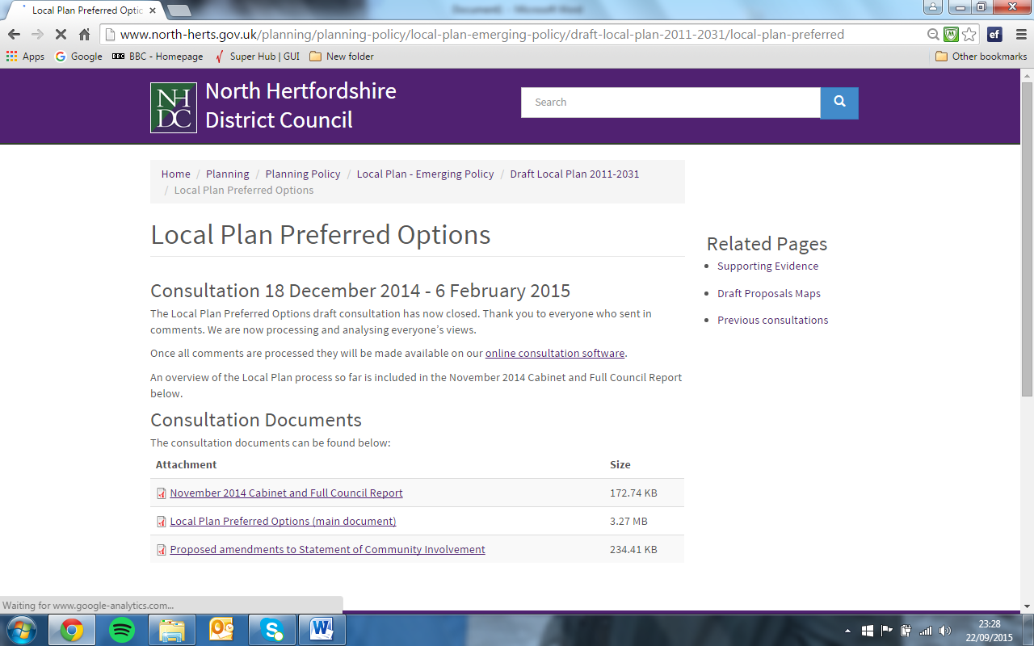 | From this screen, you can access the online consultation software by clicking the link
To view the list of documents, click on this link. | 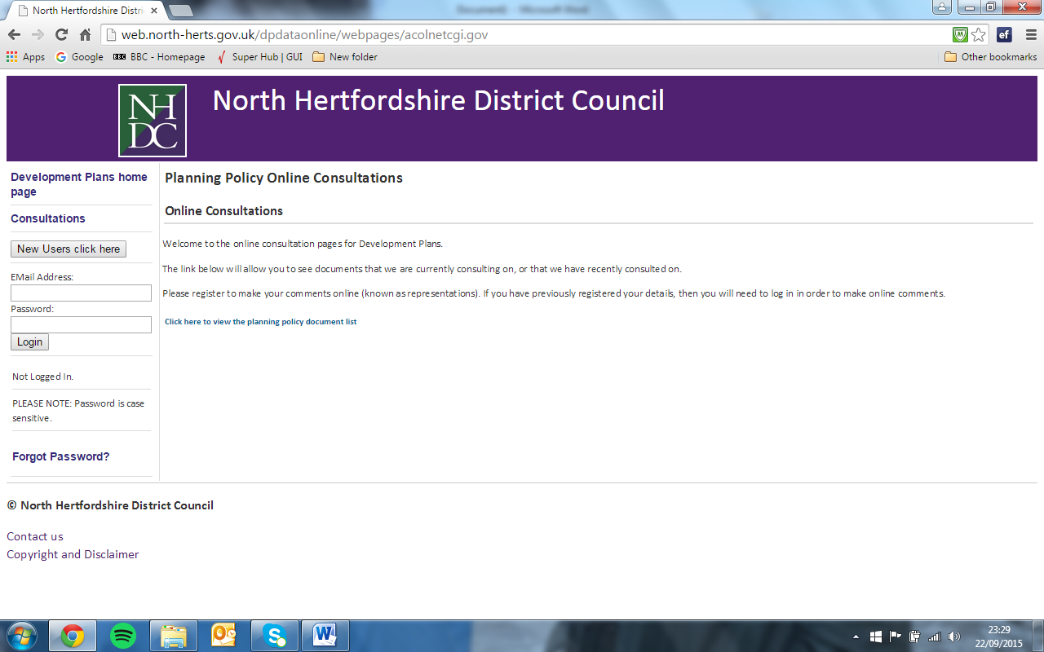
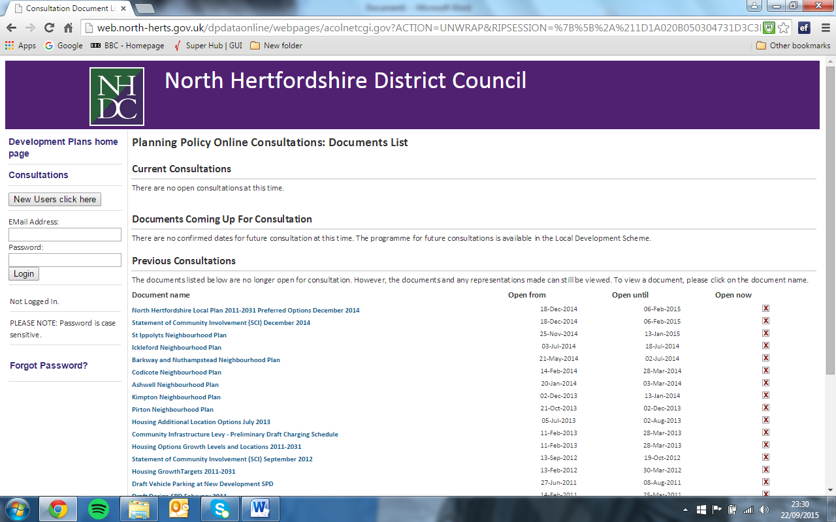 | The Local Plan Preferred Options 2011 – 2031 consultation document is at the top of the list of consultation documents. To select this, click on the link.

On the left hand side of the page, the chapters are listed numerically. If you are interested in viewing representations for the site allocations, these can be found in Chapter 12 which is towards the bottom of the list.  Use the document contents menu to select which part of the plan you are interested in. Each heading can be expanded to show the text for each policy.  Details of new sites put forward during the consultation process can be found at the bottom of this list, under the heading “New Proposed Sites”. | 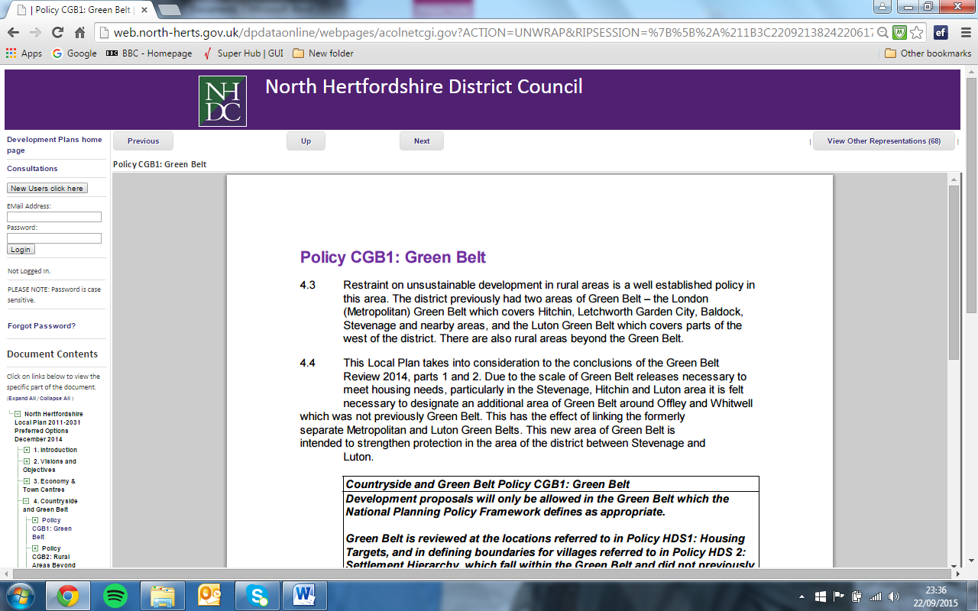
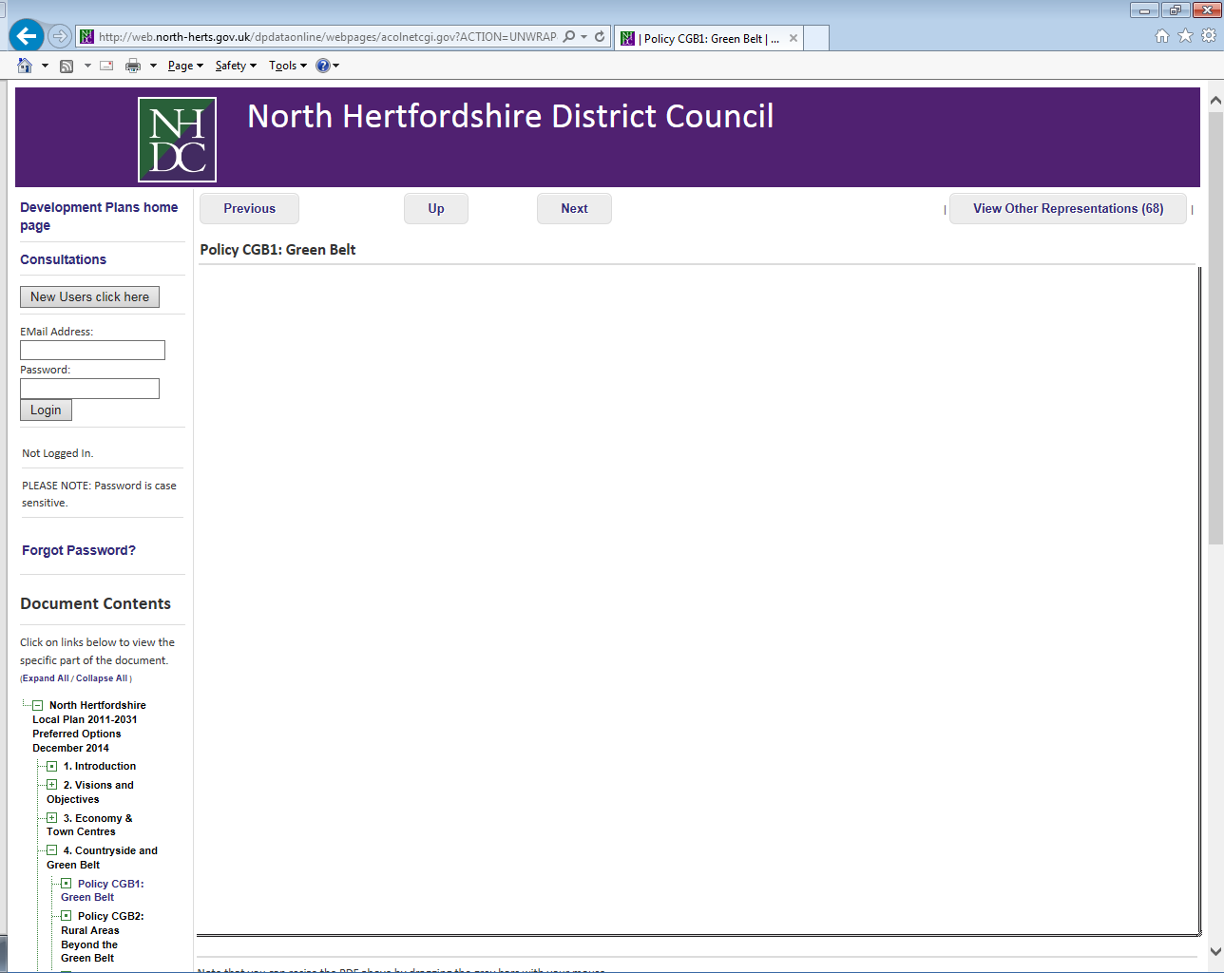 | The representations can be viewed by clicking the box at the top sight hand side of the screen.  The number of representations which have been received in respect of your chosen policy or site will be displayed in this box.
A list of representations will be displayed. To read a representation, click on the LDF reference number on the left hand side of the screen. The text of the submitted representation will be displayed. | 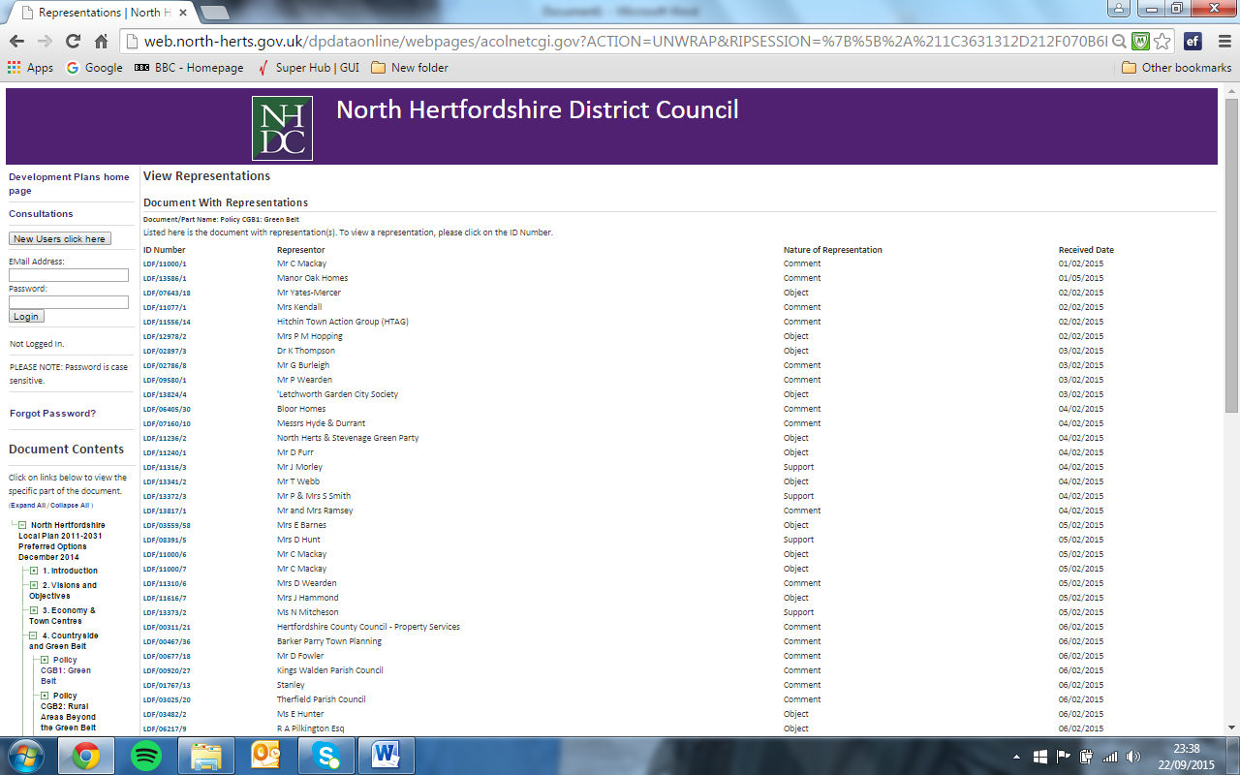
If any additional information has been received with the representation, this is listed at the end of the representations and can be viewed by clicking the link. | 