Construction and Infrastructure CO2 Management Planning

The council will develop a set of requirements which aim to manage and reduce the CO2 emissions created by all construction and infrastructure projects, which require planning and are approved by the council.
The objective would be to make these construction activities as close to being carbon neutral or ideally carbon negative. Applicants would be required to submit a CO2 Management Plan as part of their planning application.

These CO2 management plans would initially comprise two elements -

1-Management of arboricultural features at the site
2-Management and control of CO2 production

1-Management of arboricultural features at the site –
Background - The UK is one of the least wooded areas of Europe, with just 13 % woodland cover (Forest Research report 2019) compared to around 37 % for European Union (EU) countries. The UK is also currently going through a significant period of house building and infrastructure projects. Millions of trees, hedgerows and bushes are being removed to facilitate these developments.
At the same time the need to reduce CO2 emissions is now an urgent environmental crisis recognised worldwide. Current planning guidelines require landscaping and tree planting on these schemes - however what they do not require is for the replacement of the CO2 absorption properties of the trees and existing plants that have been removed. A mature tree absorbs many more times CO2 as small replacement saplings. It will take decades before these replacement plants can begin to remove the same amount of CO2 as the felled mature trees. The UK has not got that time and we need to replenish and accelerate the carbon reduction/absorption quantities from now on.
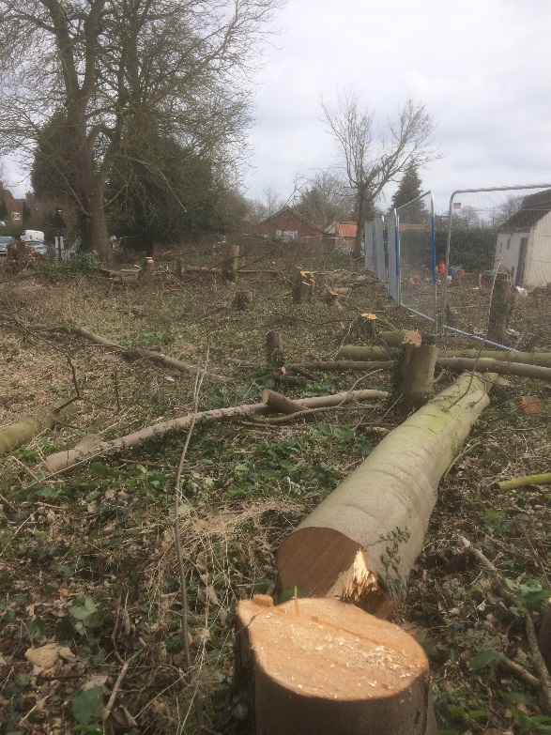 | ref – planning application 17/02812/1DOC - a new development of 19 houses in Turnpike Lane Ickleford. Approximately 59 trees with an average height of 10 meters are being removed and are being replaced with 48 new trees with an average height of just 2.8metres - a net reduction of the original carbon absorption at this site - and this does not take into account all the other bushes, shrubs and hedgerows which have been removed which also contribute to CO2 removal and absorption.

Some examples

photo of felled trees taken as construction started.
ref - planning application 18/01635/FP Walnut Tree Road Pirton. -
This development plans to remove 30 trees, the majority of which are in excess of 12 metres high and replace them with 33 new trees the size of which is unspecified, however looking at the size and scaling on the applicants drawings they will be small saplings perhaps a metre or two high - a net reduction of the original carbon absorption at this site.

Current planning rules do not require like for like replacement of trees and shrubbery. All over the UK CO2 absorption is being lost as insufficient tress are being planted to replace those lost on construction sites and infrastructure projects,
A like for like CO2 absorption requirement will help stop this decline.
Obtaining planning permission needs to incorporate a condition that all building developments, construction and infrastructure projects are required to replace the CO2 absorption rates lost by the removal of trees, saplings and hedgerows due to the proposed works - by the end of the project.

This also presents an opportunity for the council to improve amenity spaces and protect our precious countryside. If you look at a map of North Herts you will see that the space between towns and villages has been declining over many decades such that there now only exists one or two fields or wild areas that prevent our towns and villages from becoming one large urban sprawl.
Look at Hitchin and Ickleford, Gosmore and Hitchin, St Ippolytts and Gosmore, Little Wymondley and Stevenage, Hitchin and Letchworth - all only separated by one or two arable fields or pastures.
If this new policy is adopted developers will be looking for sites to plant the additional trees required to offset their CO2 activities on their sites. If the council can influence the landowners these spaces could be planted and become new forests keeping the identity of these settlements separate and would also improve the outlook and landscaping for many residents whose current view is houses from the next settlement.

2 – Management and control of CO2 production

As part of the planning application the applicant will submit a CO2 Management and Control plan. This plan should deal with practices both on and off site which generate CO2 and include plans to minimise this so as to generate the least CO2 as possible.

Diesel and petrol powered equipment is used extensively on construction sites, - quite often these machines will be left running for hours or all day even when not being used. It used to be that diesel engines used less fuel being left running rather than being switched on and off through the day. The technology to make it efficient to switch these machines off and on when not required is readily available, and there is a need a for a perception change here. This plan should look at the use of electric machinery and vehicles where possible, and include electric charge points on site. These charging points should be incorporated into the development for the end users. Where no electrical supply is available renewable energy should be used where possible to provide temporary site electricity rather than Diesel generators.

An example of a current construction site

https://youtu.be/nPRViK1cuW4

The video in this link relates to a current construction site being operated by Cala Homes in Pirton

It shows a blue container, which is a diesel generator required to provide electricity for the site offices. This generator has been running for in excess of a year – sometimes continuously 24 hours a day. You will also see the site offices have large flat roofs which could accommodate solar panels for electricity generation. There is also space in the compound for a wind turbine. Finally, you will see existing power lines running adjacent to the site, which could have provided temporary electricity for the site offices.

The front of this site has had permanent electrical supplies connected to the new properties for several months so again a temporary electrical supply could have been installed from here to the site offices rather than relying on the diesel generator.

The final part of this plan should identify what CO2 reduction opportunities the applicant has built into their development.
These should consider and include where possible –
- Charging points for electric vehicles
- Solar panels for electricity generation
- Wind turbine for electricity generation.

